# 

**Equality**

**Outcomes**

**Final Progress**

**Report**

**2023-2025**

CONTENTS

Introduction **Error! Bookmark not defined.**

Purpose 5

External Influences **Error! Bookmark not defined.**

Evidence of Progress **Error! Bookmark not defined.**

Looking Forward **Error! Bookmark not defined.**

Appendix A: Equality Outcomes 2021-2025 final Action Plan **Error! Bookmark not defined.**

# Introduction

# Glasgow Clyde College is one of the largest Further Education providers in Scotland.

Across our three friendly campuses in Anniesland, Cardonald and Langside, we offer hundreds of innovative, flexible full-time and part-time courses that can expand your mind and your skills.

You can make leaps in your career, surprise yourself with new abilities and take the next steps to further study.

It doesn’t even matter whether you don’t know what to do just yet. We’ll show you what’s possible and we’ll be with you every step of the way, even if you change your mind.

We believe it’s not always the big stuff that adds up to big changes. It’s small, everyday things, like supportive staff and a safe space to study, helpful, kind lecturers and connections to employers and universities who can show you the way forward.

We are a people-centred community, and an unrivalled student experience and sense of belonging is at the heart of everything we do.

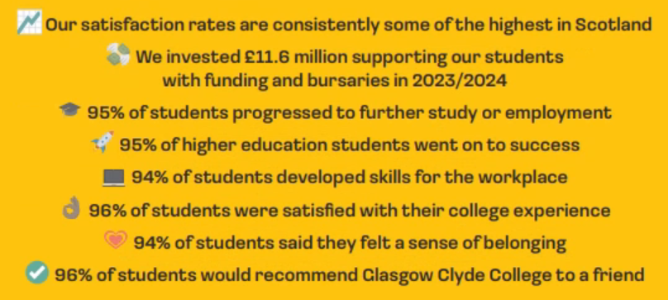

# We are an equal opportunities employer and positively encourage applications from suitably qualified and eligible candidates regardless of sex, race, disability, age, sexual orientation, gender reassignment, religion or belief, marital status or pregnancy and maternity.

# Our college Values are:

# People-centred, Pioneering, Principled and Passionate

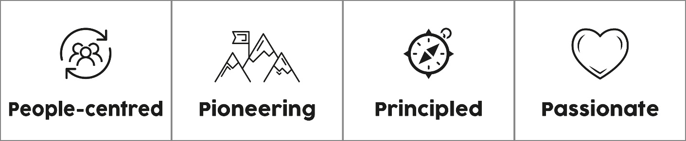

# [Find out more about our Values, as well as our Mission and Vision](https://www.glasgowclyde.ac.uk/assets/000/005/478/Mission-Vision-Values_A4_original.pdf).

# SCQF Inclusive Recruiter

# We’re an SCQF Inclusive Recruiter. Find out more about [SCQF Inclusive Recruiters here](https://scqf.org.uk/support/support-for-employers/scqf-inclusive-recruiter-wall/).

# SCQF inclusive recruiter

# Glasgow Living Wage

# We’re a Glasgow Living Wage employer. [Find out more about the Living Wage](https://www.glasgowclyde.ac.uk/assets/000/006/789/Glasgow_Living_Wage_original.pdf).

# We're committed to being [Menopause Friendly](https://menopausefriendly.co.uk/)

# Menopause Friendly Committed

# Purpose

**Purpose of Equality Outcomes**

*"Listed authorities must publish a report on the progress made to achieve their equality outcomes every two years. This ensures transparency and accountability in how public authorities are working towards advancing equality and eliminating discrimination."*

[EHRC Scotland Reporting Duties Guidance](https://www.equalityhumanrights.com/guidance/public-sector-equality-duty/public-sector-equality-duty-specific-duties-scotland)

Equality outcomes are essential for advancing equality and improving life chances for individuals over a four-year period. In Scotland, institutions are required to publish a set of equality outcomes and report on progress every two years. These outcomes help institutions fulfil their Public Sector Equality Duties (PSED) by addressing persistent inequalities and promoting fairness and inclusion.

**What are Equality Outcomes?**

Equality outcomes are strategic goals that institutions aim to achieve to improve the life chances of individuals, particularly those from disadvantaged groups. These outcomes are designed to bring practical improvements to the lives of those who experience discrimination and disadvantage.

**Glasgow Clyde College’s Equality Outcome Progress Report**

To better perform the Public Sector Equality Duties (PSED), Glasgow Clyde College’s Final Equality Outcome Progress Report will detail our:

* Duty to publish a report on the progress made to achieve the published equality outcomes.

The purpose behind progressing our equality outcomes is to help further the needs mentioned in the general equality duty, which includes eliminating unlawful discrimination, advancing equality of opportunity, and fostering good relations between different protected characteristic groups

**New National Equality Outcomes and Guidance**

**Scottish Funding Council (SFC) National Equality Outcomes**

The Scottish Funding Council (SFC) has introduced new National Equality Outcomes (NEOs) to address persistent inequalities in the tertiary education sector. These NEOs focus on key areas such as:

* Success and retention rates of students.
* Satisfaction levels of disabled students.
* Gender imbalances in courses.
* Mental health of staff and students.
* Safety of students and staff.
* Proportionate representation of staff and Boards particularly in relation to race and disability

Colleges are strongly encouraged to adopt the NEOs that are relevant to their context and to set meaningful action plans to achieve these outcomes.

**SFC Guidance to Colleges**

The SFC provides detailed guidance to support colleges in developing and reporting on their equality outcomes. This guidance includes:

* Setting equality outcomes that are SMART (specific, measurable, achievable, relevant, time-bound).
* Ensuring equality outcomes bring practical improvements to the lives of those who experience discrimination and disadvantage.
* Reporting on progress towards achieving the NEOs and measuring impact using available data

**Glasgow Clyde College’s Equality Outcomes 2021-2025**

1. Recruitment of a diverse workforce, particularly those from black and minority ethnic backgrounds and disabled individuals, which will cultivate an inclusive and innovative college community

2. Staff and students at Glasgow Clyde feel a sense of belonging and are confident they will thrive in a safe and supportive college community

3. Our services respond to and meet the needs of all disabled staff and students, including those with a mental health condition.

4. Staff are fully supported to create and deliver an inclusive curriculum

Glasgow Clyde College’s Equality Outcomes for 2021-2025 were published in April 2021, detailing how they were devised. The related reports are available on our website [**here**](https://www.glasgowclyde.ac.uk/about-us/equality-and-inclusion)

This report will show progress made in the last two years (2023-2025) in achieving these outcomes and will help to evidence the development and creation of our new equality outcomes in the separate report "New Equality Outcomes 2025-2029"

# External Influences

**External Influences on Glasgow Clyde College's Equality Outcomes 2021-2025**

**Public Sector Equality Duty (PSED)**

The Public Sector Equality Duty (PSED) consists of a general duty under the Equality Act 2010 and specific duties outlined in The Equality Act 2010 (Specific Duties) (Scotland) Regulations 2012, amended by The Equality Act 2010 (Specific Duties) (Scotland) Amendment Regulations 2016. These duties are designed to assist public bodies in Scotland in meeting the general duty.

[Public Sector Equality Duty: specific duties in Scotland | EHRC](https://www.equalityhumanrights.com/guidance/public-sector-equality-duty/public-sector-equality-duty-specific-duties-scotland)

**Scottish Government's Student Mental Health Action Plan**

The Scottish Government's Student Mental Health Action Plan, published in September 2024, aims to enhance student mental health and wellbeing through effective collaborative working across colleges, universities, NHS Boards, Integrated Joint Boards, Public Health Scotland, Health and Social Care Partnerships, and the third sector. This plan emphasizes prevention, early detection, and access to appropriate treatment, ensuring that student wellbeing is a core focus.

[Introduction - Student mental health action plan - gov.scot](https://www.gov.scot/publications/student-mental-health-action-plan/pages/2/)

**Scottish Funding Council (SFC) and Memorandum of Understanding**

The Scottish Funding Council (SFC) continues to play a crucial role in advancing equality within the tertiary education sector. The Memorandum of Understanding (MoU) between the SFC and the Equality and Human Rights Commission (EHRC) strengthens joint working to promote equality for college and university students and staff. The SFC's National Equality Outcomes (NEOs) report, published in January 2025, outlines persistent inequalities in the tertiary system and calls for institutions to address these issues as part of their Public Sector Equality Duty.

[Together for equality - Scottish Funding Council](https://www.sfc.ac.uk/together-for-equality/)

**Tackling Persistent Inequalities Together**

The SFC's report, "Tackling Persistent Inequalities Together," published in January 2025, outlines the persistent inequalities in the tertiary education system and asks institutions to address them by contributing to a set of National Equality Outcomes (NEOs) as part of their Public Sector Equality Duty. Glasgow Clyde College will progress its Equality Outcomes in accordance with these new NEOs.

By incorporating these national drivers and influences, Glasgow Clyde College ensures that our Equality Outcomes 2021-2025 were progressed and sectoral evidence supports the development of our new Equality Outcomes 2025-2029.

[Tackling persistent inequalities together](https://www.sfc.ac.uk/wp-content/uploads/uploadedFiles/Tackling_persistent_inequalities_together.pdf)

# Evidence of Progress

Glasgow Clyde College has made meaningful progress from May 2023 to March 2025 in achieving the equality outcomes set for the period 2021-2025. The college has made significant strides in promoting equality, diversity, and inclusion, aligning with the three general equality duties in Scotland: eliminating discrimination, advancing equality of opportunity, and fostering good relations. The measurement of this progress can be evidenced by the following achievements and initiatives:

**Progress and Achievements**

**Nurture College:** The college approach to nurture was formally launched at the start of session 23/24. This was the culmination of numerous meetings with Glasgow City Council educational psychologists and different experts in this field during session 22/23. It was agreed by SLT to make this approach a key priority for the whole college to change how it interacted with young people and supported them in their time at college. Nurture Action Plan – 16 of the 19 actions are on track for completion by June 2025

**Gender-Based Violence (GBV) Prevention and Support**

**EmilyTest GBV Charter**: Glasgow Clyde College successfully achieved the EmilyTest GBV Charter Award, demonstrating its commitment to preventing and addressing gender-based violence. The college implemented comprehensive training programs for staff and students, established clear reporting mechanisms, and provided support services for survivors.

**Menopause Accreditation**

**Menopause Friendly Accreditation**: The college received the Menopause Friendly Accreditation, recognising its efforts to create a supportive environment for staff experiencing menopause. Initiatives included awareness campaigns, training for managers, and adjustments to the physical work environment to accommodate symptoms

**Wellbeing Strategies and Initiatives**

**Brothers In Arms Partnership**: Glasgow Clyde College partnered with Brothers In Arms to support men's mental health. The initiative included workshops, digital tools, and conversation channels to promote mental resilience and well-being among male students and staff

**Mental Wellbeing Strategies**: The college has developed Stay Well & Thrive initiative for all students and staff, mental health first aid training, new Safeguarding procedures and awareness campaigns to reduce stigma and encourage help-seeking behaviour.

**LGBT Youth Scotland Charter Mark**

**LGBT Youth Scotland Charter Mark Silver**: The college maintains its LGBT Youth Scotland Charter Mark Silver status, reflecting its ongoing commitment to creating an inclusive environment for LGBTQ+ students and staff. Activities included celebrating LGBTQ+ events, providing training on LGBTQ+ issues, and ensuring policies and practices are inclusive

**GCCSA Projects and Partnerships**

**GCCSA Initiatives**: The Glasgow Clyde College Student Association (GCCSA) led various projects to enhance student engagement and support. These included a new module for all Class Reps with relevant EDI information and resources and partnerships with local organisations to provide additional resources and support for students

**Education Scotland Review Report Sept 2024**

**Positive Inspection Reports**: Education Scotland conducted reviews of the college, highlighting areas of effective practice and providing recommendations for further improvement. The college used these insights to enhance its educational offerings and support services, ensuring they meet the diverse needs of all students. Areas of positive progress included- “*Managers and staff work well together to provide a nurturing environment for learners. Early indications suggest this is impacting positively on learner withdrawal and success rates.”*

*“Successful applicants access a range of helpful advice and support prior to starting programmes through the Get Ready for Clyde initiative. There are indications that this is impacting positively on early retention.”*

No ‘Main Points for Action’ were identified.

**Retention and Attainment Student Data**

**Student Satisfaction Surveys:** The total number of students rating their experience as "Excellent" or "Good" rose from 2352 in 2023/2024 to 2991 in 2024/2025, a 27.22% increase in the Early Impressions Student Surveys 2023-2024 and 2024-2025 with positive trends across most protected characteristics.

Further student data and outcomes can be found within our [2025 Mainstreaming Report.](https://www.glasgowclyde.ac.uk/assets/000/008/419/Equality_Mainstreaming_Report_2025_original.pdf?1745837278)

**See** our Equality Outcomes Action Plan 2023-2025 in **Appendix A** for further examples of activities and initiatives.

Glasgow Clyde College has made substantial progress in achieving its equality outcomes for 2021-2025. The initiatives and partnerships highlighted demonstrate the college's commitment to promoting equality, diversity, and inclusion. By continuing to build on these successes and addressing areas for improvement, the college will develop Glasgow Clyde College’s 2025-2029 equality outcomes, ensuring continued progress toward a more inclusive learning environment.

# Looking Forward

As we look ahead, Glasgow Clyde College has diligently worked to assess our progress and identify areas for improvement. This evaluation has informed the creation of new equality outcomes for the period 2025-2029. These outcomes have been developed in alignment with the Scottish Funding Council's (SFC) National Equality Outcomes, ensuring that our efforts are consistent with national priorities and address persistent inequalities on a broader scale.

The SFC's National Equality Outcomes focus on tackling significant inequalities that affect various groups across Scotland. The SFC encourages institutions to adopt these outcomes and integrate them into their strategic planning to ensure a cohesive approach to advancing equality.

In line with these recommendations, Glasgow Clyde College has created a new SMART action plan template. This template is designed to set Specific, Measurable, Achievable, Relevant, and Time-bound objectives, ensuring that our new equality outcomes are not only ambitious but also attainable and impactful.

The College is currently developing new self-evaluation protocols as we embark on our quality journey with QAA.  This will enable us to consider the best ways to embed and reflect upon EDI within the curriculum and support services and highlight the extensive partnership working that we undertake with external organisations.  We have submitted our initial Self Evaluation Action Plan and will be discussing our quality evolution with QAA over the coming months and years as we continuously improve of learning, teaching and support services across the College.

We are committed to fostering an inclusive environment where every individual can thrive, and we look forward to working collaboratively with our college community and partners to achieve our new equality outcomes. Together, we will continue to advance equality, eliminate discrimination, and promote good relations within our college and beyond.

**Appendix – Final Action Plan**

