# 

**Equality**

**Mainstreaming**

**Report**

**2023-2025**

CONTENTS

Principal’s Foreword 3

Introduction 4

Purpose 5

Staff Summary 6

Student Summary 7

External Influences 8

Commitment 9

Progress 10

Staff Monitoring Data and Analysis 11

College Board of Management Information 12

Looking Forward 13

# Principal’s Foreword

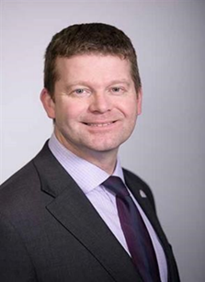

Throughout Glasgow Clyde College, there is a profound commitment and restless desire to provide a truly inclusive environment, valuing and respecting diversity and ensuring equality of opportunity for everyone in each and every aspect of our work. This commitment is encapsulated in our College values of being ‘people-centred’, ‘principled’, ‘pioneering’ and ‘passionate’. It is these values which define our organisational culture and set us apart.

We take pride in our pioneering work to embed a nurturing approach throughout the College, ensuring that all students feel supported, valued, and encouraged to thrive. This commitment has been further reinforced by our recent achievement of the Emily Test Charter, demonstrating our dedication to creating a safe and inclusive environment for everyone.

We work tirelessly in partnership with our members of staff, students, employers, and partners to break down barriers to opportunity, participation, and attainment in order to equip and empower our students to fulfil their potential and improve their life chances. By challenging stereotypes, developing understanding, and confronting prejudice, we foster good relations between those who share protected characteristics and those who do not. We are proud of the progress we have collectively made to advance the mainstreaming of equality, diversity, and inclusion within College practices and procedures.

Glasgow Clyde College acknowledges the progress we have made in achieving our College Equality Outcomes and Mainstreaming. However, we are not complacent and will continue striving to improve the quality of the services we provide to those who face the greatest challenges. We are confident that our vision for equality, diversity, and inclusion will act as a catalyst to deliver the requirements of the Equality Duty.

Looking ahead, we will reinforce our steadfast commitment to equality, diversity, and inclusion in our new strategic plan, which will be launched in late 2025. This plan will outline our continued efforts to promote an inclusive culture where everyone is respected, empowered, and provided with equal opportunities to succeed.

The challenge ahead of us is to tackle and eradicate the persistent inequalities which have so stubbornly impacted the experiences of students in the college sector for too long. We will achieve this by dedicating our energies to meeting the National Equality Outcomes as part of our Public Sector Equality Duty. The College staff, Board of Management, Student Association, and I will continue to work with the shared goal of nurturing a culture where everybody feels able to be themselves in an environment that is welcoming, safe, respectful, and ambitious.

Thank you for taking the time to read this report.



Jon Vincent Principal and Chief Executive, Glasgow Clyde College

# Introduction

# Glasgow Clyde College is one of the largest Further Education providers in Scotland.

# Across our three friendly campuses in Anniesland, Cardonald and Langside, we offer hundreds of innovative, flexible full-time and part-time courses that can expand your mind and your skills.

# You can make leaps in your career, surprise yourself with new abilities and take the next steps to further study. It doesn’t even matter whether you don’t know what to do just yet. We’ll show you what’s possible and we’ll be with you every step of the way, even if you change your mind.

# We believe it’s not always the big stuff that adds up to big changes. It’s small, everyday things, like supportive staff and a safe space to study, helpful, kind lecturers and connections to employers and universities who can show you the way forward.

# We are a people-centred community, and an unrivalled student experience and sense of belonging is at the heart of everything we do.

# We are an equal opportunities employer and positively encourage applications from suitably qualified and eligible candidates regardless of sex, race, disability, age, sexual orientation, gender reassignment, religion or belief, marital status or pregnancy and maternity.

# Our college Values are:

# People-centred, Pioneering, Principled and Passionate

# 

# [Find out more about our Values, as well as our Mission and Vision](https://www.glasgowclyde.ac.uk/assets/000/005/478/Mission-Vision-Values_A4_original.pdf).

# SCQF Inclusive Recruiter

# We’re an SCQF Inclusive Recruiter. Find out more about [SCQF Inclusive Recruiters here](https://scqf.org.uk/support/support-for-employers/scqf-inclusive-recruiter-wall/).

# SCQF inclusive recruiter

# Glasgow Living Wage

# We’re a Glasgow Living Wage employer. [Find out more about the Living Wage](https://www.glasgowclyde.ac.uk/assets/000/006/789/Glasgow_Living_Wage_original.pdf).

# We're committed to being [Menopause Friendly](https://menopausefriendly.co.uk/)

# Menopause Friendly Committed

# Purpose

# What is Mainstreaming?

# Mainstreaming equality means integrating equality into the day-to-day operations of an institution. In Scotland, there is a specific duty for institutions to mainstream equality across their functions. This approach ensures that the entire institution is committed to fulfilling its public sector equality duty.

# To better perform the Public Sector Equality Duties (PSED), Glasgow Clyde College’s Equality Mainstreaming Report will detail our:

# • Progress on mainstreaming the general duty (to eliminate discrimination, advance equality of opportunity, and foster good relations) into all functions.

# • Progress made in gathering and using information on the protected characteristics of staff.

# Equality Act and Public Sector Equality Duty

# The foundations of the Equality Act 2010 Public Sector Equality Duty (PSED) are eliminating discrimination, advancing equality, and fostering good relations. This duty requires that:

# A public authority must, in the exercise of its functions, have due regard to the need to:

# a) Eliminate discrimination, harassment, victimisation, and any other conduct prohibited by the Act

# b) Advance equality of opportunity between persons who share a relevant protected characteristic and persons who do not share it

# c) Foster good relations between persons who share a relevant protected characteristic and persons who do not share it.

# All staff are responsible for ensuring that the Public Sector Equality Duty is embedded in all functions and activities. This is what is meant by mainstreaming equality.

# Equality and Human Rights Commission (EHRC)

# The EHRC continues to provide guidance on the implementation of the Equality Act 2010, emphasising the importance of intersectionality and the need to consider multiple, overlapping forms of discrimination when developing policies and practices.

# Scottish Government

# The Scottish Government's commitment to a just and fair society includes embedding equality, inclusion, and human rights into all government policies and practices. This approach is critical to creating a society where everyone can reach their full potential.

# By incorporating these updates and definitions, Glasgow Clyde College can ensure that its Equality Mainstreaming Report reflects the latest standards and commitments across the sector.

# Staff Summary

Our people management strategies are of primary importance.  We strongly believe that by investing in our staff, we will provide the best possible learning experience for our students.

Please see our annual People reports from 2022-2023 & 2023-2024 in the link below.

[Annual People Report | Glasgow Clyde College](https://www.glasgowclyde.ac.uk/about-us/annual-people-report)

The following information provides an overview of our People and further data can be found later under Staff Monitoring Data and Analysis. The purpose of this is to collect data on the characteristics of the establishment's staff, including their gender, age, ethnicity, religion, sexual orientation, and disability status. It also presents the findings of monitoring, highlighting key trends and patterns in the data, as well as areas where there may be opportunities for improvement with respect to promoting diversity, inclusivity, and equality of opportunity within the establishment. The information provides a valuable resource for the college's leadership team and other stakeholders in their efforts to create a supportive and inclusive environment for all staff members.

Data from 14th February 2025 shows, Glasgow Clyde College staff headcount was 980. Of this, 583 were female and 307 were male.

Changes since 2023 report

|  |  |  |  |
| --- | --- | --- | --- |
|  | 2023 Report | 2025 Report | % Difference |
| Female | 64% | 66% | +2% |
| Male | 36% | 34% | -2% |

The sex (gender) distribution of staff at Glasgow Clyde College is an important factor to consider, but it should not be the sole focus. Ensuring that all employees, regardless of sex or gender, are treated fairly and equitably, with equal access to career development opportunities and benefits, remains a priority.

While a gender imbalance in the workforce may prompt concerns about potential biases in recruitment and promotion, it may also reflect the availability of qualified candidates in the relevant job market.

Therefore, it is essential to examine the root causes of any imbalance. Steps have been taken to address potential issues, including ensuring fair and unbiased recruitment and promotion processes, fostering a diverse and inclusive workplace, and providing training and career development opportunities for all staff.

**Age groupings and sex (gender)**

The graph below, depicts the age distribution of staff by sex. Data is shown as a percentage of the overall number of staff. It is evident that the largest number of male staff are in the 56-65 age group, and the largest number of female staff are in the 46-55 age group.

The age profile of staff at Glasgow Clyde College is an important factor in workforce planning and succession management. However, a concentration of staff within a particular age group is not necessarily a concern in itself.

A workforce that includes a diverse range of ages and experience levels brings valuable perspectives and skills to the organisation. At the same time, we recognise the need to attract and retain younger staff to ensure a strong talent pipeline for the future.

Age groups by category of role, shows that all age groups show a similar pattern between lecturing and support staff. When analysing the age group of 56-65 years, the age leading up to when staff can access their pension and may retire, these are spread across Lecturing (16.2%) and Support (13.2%) roles in similar percentages, with a smaller percentage (0.34%) in senior management.

Notably, despite the estimated retirement age being around 65–67, there are 32 employees in the 66+ age group.

As ageing workforces become an increasing challenge across many sectors, it is essential to balance experience retention with proactive succession planning. This includes supporting career progression, knowledge transfer, and workforce sustainability to maintain our college’s resilience.

**Sexual Orientation**

The chart below shows the distribution of staff by their defined sexual orientation. Data is shown as a percentage of the overall number of staff.

When compared with December 2024 data from [Understanding Glasgow | The Glasgow Indicators Project](https://www.understandingglasgow.com/), GCC has,

* 79% of staff identify as heterosexual, which is lower than Glasgow's average of 84%.
* 4% of staff identifying as; gay men (1%), gay women/lesbians (1%), or bisexual (2%). This is slightly lower than Glasgow's average, where 7.2% identify as bisexual (3.1%), gay or lesbian (3.1%), or other sexual orientations (1.0%).
* A significant 17% of our staff chose not to disclose their sexual orientation, which is higher than the approximately 8% non-response rate observed in Glasgow's population.

These disparities suggest that our workplace has a higher rate of non-disclosure and a lower representation of LGBTQ+ individuals compared to the broader Glasgow population. These findings suggest that there may be a need for increased awareness and support for staff members who identify as LGBTQ+.

In improving the accuracy and inclusivity of our data to reflect Glasgow's demographics, we have taken steps. Firstly, we have communicated awareness around the importance of diversity monitoring by sharing how the data is used to support inclusion initiatives. We hope that by encouraging staff to disclose their sexual orientation by ensuring anonymity and explaining the purpose of data collection, this may help reduce the high non-disclosure rate (17%) compared to Glasgow’s average (8%). Additionally, we promote an open and inclusive workplace culture through awareness campaigns, LGBTQ+ staff networks. We are also looking at allyship programs to foster an environment where employees feel more comfortable self-identifying. We have reviewed and updated our data collection methods, to ensure that staff provide a response to all sensitive data questions.

**Religious Beliefs**

Data is shown as a percentage of the overall number of staff.

Based on the snapshot data, most staff at our staff state they have ‘no religious beliefs’ at 30.79%. The second largest group, 23.93%, consists of staff who prefer not to disclose their religious affiliation. This has changed from the previous report, where the majority chose, ‘prefer not to say’ and the 2nd highest were those who stated ‘no religious beliefs’.

Among those who have disclosed their religious beliefs, the dominant faiths are Roman Catholic at 17.3% and Protestant at 13.7%.

Previous findings highlighted the need to enhance inclusivity and respect for diverse religious beliefs and non-belief in the workplace. In response, we have focused on improving the recording of sensitive data and addressing staff concerns about sharing this information. By clearly communicating the purpose and importance of data collection to both current and prospective employees during recruitment, we have helped reduce reluctance in disclosure. As a result, the proportion of staff choosing not to disclose their religious affiliation has decreased from 32.9% in our previous report, to 23.9% this year.

**Ethnicity**

In terms of ethnic origin, the data indicates that most staff at Glasgow Clyde College identify as ‘white’, with 785 individuals (88%). The numbers for other ethnic groups, including Indian, Pakistani, African, Chinese, and others, are grouped together under Black, Minority Ethnicities (BME) and are relatively low, with 32 individuals (4%). A further 73 (8%) employees have chosen not to disclose their ethnicity.

Based on our previous years report, our BME grouping has risen from 2.74% to 4%. Data is shown as a percentage of the overall number of staff.

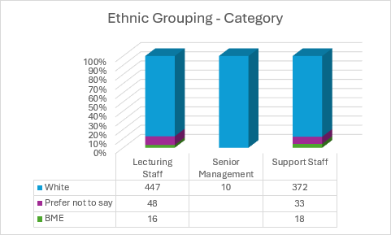

Ethnic groups within our categories of staff, show that BME staff are represented in both lecturing and support staff groups in similar numbers. There are no BME staff at senior management level.

**Disability**

76% employees have declared no disability, whilst 19% prefer not to say and 5% have declared a disability. This highlights the importance of ensuring that staff feel comfortable and supported in disclosing any disabilities, and that the College provides an inclusive and accommodating environment for all employees.

Staff who have disclosed a disability are present across all 3 categories of staff, with 2.36% of those who have declared a disability in Lecturing staff, 2.36% in Support staff and 0.22% within SLT. Percentages shown are of total staff.

# Student Summary

**Student Diversity and Success Rates**

*Source Course PIs by PC 2022-2023 & 2023-2024*

**Total students enrolled:**

2022-2023: 14437 2023-2024: 12699

From over 156 nationalities in 2023/2024

**Overall College Success Rate:**

* 1. – 68% 2023/24: 66.8%

In almost all modes of study, strike action in session 2023-2024 impacted negatively on pass rates in the college, by between 2.5 and 5%.  In what could have been a resurgent year for the college, following promising early withdrawal figures in October, success rates declined in all categories except PT HE.  Over 30 days of strike action, unprecedented in the sector, interrupted classroom delivery and assessment schedules.  A resulting boycott meant that many learners were not given results of assessments they did sit, which removed any motivation for them to either stay on the course or aim to improve. For students on apprenticeships, the withholding of results also prevented them receiving pay rises linked to unit their achievement of academic milestones.  It is telling that the college has posted record retention levels in its first uninterrupted year of delivery since the pandemic.

# 

Encouragingly however, early withdrawal rates have improved significantly over the last 3 years and are now at an all time low for Glasgow Clyde College.  Full-time FE and full-time HE has more than halved with less that 6% of students now withdrawing before the census date.  Part-time FE and part-time HE withdrawal has also declined by more than 25% in the same period, following a slight rise in HE Part-time withdrawal rates in session 23/24.  Industrial action in 23/24 did not significantly affect early withdrawal rates as most industrial action took place later in the year, after this metric is calculated.

Further Withdrawal rates have also improved significantly in the last 3 years, following significant downturns in session 23/24 as a consequence of the industrial action.  In session 24/25 we anticipate modest improvements in FE retention and significant improvements in HE retention.

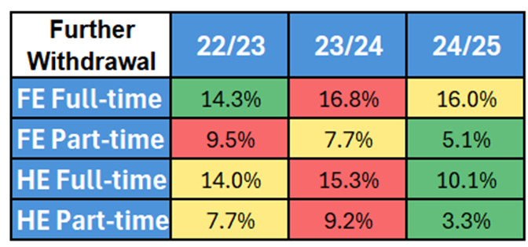

**Sex**

Percentage of Female & Male Learners

2023/24

* Female (including Trans women): 51.4%
* Male (including Trans men): 47.7%
* Prefer not to Say: 0.9%

2022/23:

* Female (including Trans women): 52.7%
* Male (including Trans men): 46.7%
* Prefer not to Say: 0.7%
* Female success rate: 67.1%
* Male success rate: 66.6% both still similar or above the college overall percentage

**Age**

* 16-19-year-olds: Success rate increased from 60.6% to 60.9%.
* 35-49-year-olds: Highest success rate at 74.4%.

**Ethnicity**

* BME student success rate: 69.6% (↓ from 71.6%) but still significantly higher than the overall college success rate.
  + African: 76.2%
  + Chinese and other Asian background: 82.2%
  + Pakistani: 58.7% (significantly lower)
  + Arab: 72.7%
* White student success rate: 65.3%

**Sexual Orientation**

* Bi/Bisexual student success rate: 61.7% (↑ from 56.1%).
* Overall LGBTQI+ student success rates improved.

**Gender Identity**

2023/24:

* Total Trans Students (Prefer not to say - 1088): 906

2022/23:

* Total Trans Students (Prefer not to say- 1238, Did not answer 105): 1,071

Positive trend in reducing the number of ‘Prefer not to say’ and no further ‘Did not answer’

**Disability**

* 17.7% of students declared a disability.
* Mental health condition success rates improved from 57.4% to 60.5%.

**Religion & Belief**

2023/24 Academic Year:

* Total Students Enrolled: 12,699
* Students with a Religion: 7,315 (57.6%)
* Students with No Religion: 5,384 (42.4%)

2022/23 Academic Year:

* Total Students Enrolled: 14,437
* Students with a Religion: 8,119 (56.2%)
* Students with No Religion: 6,318 (43.8%)

Despite having slightly less students enrolled, there was an increase of 1.4 % of those with a ‘Religion or Belief’ as well as a reduction in ‘Prefer Not to Say’.

**Socioeconomic Status (SIMD 20%)**

* Success rate decreased from 66.9% to 65.8%, 1% less than the college overall success rate. 50% of enrolments in 2022-2023 were from those in SIMD10 & SIMD 20 areas (33% SIMD 10, 17% SIMD20). 70% of total enrolments came from SIMD deciles 10--40

**Care Experienced Learners**

* Enrolment dropped from 970 to 848 but success rate improved slightly from 56.1% to 56.6%

**Student Satisfaction in Early Impressions Surveys 2023-2024 Vs 2024-2025**

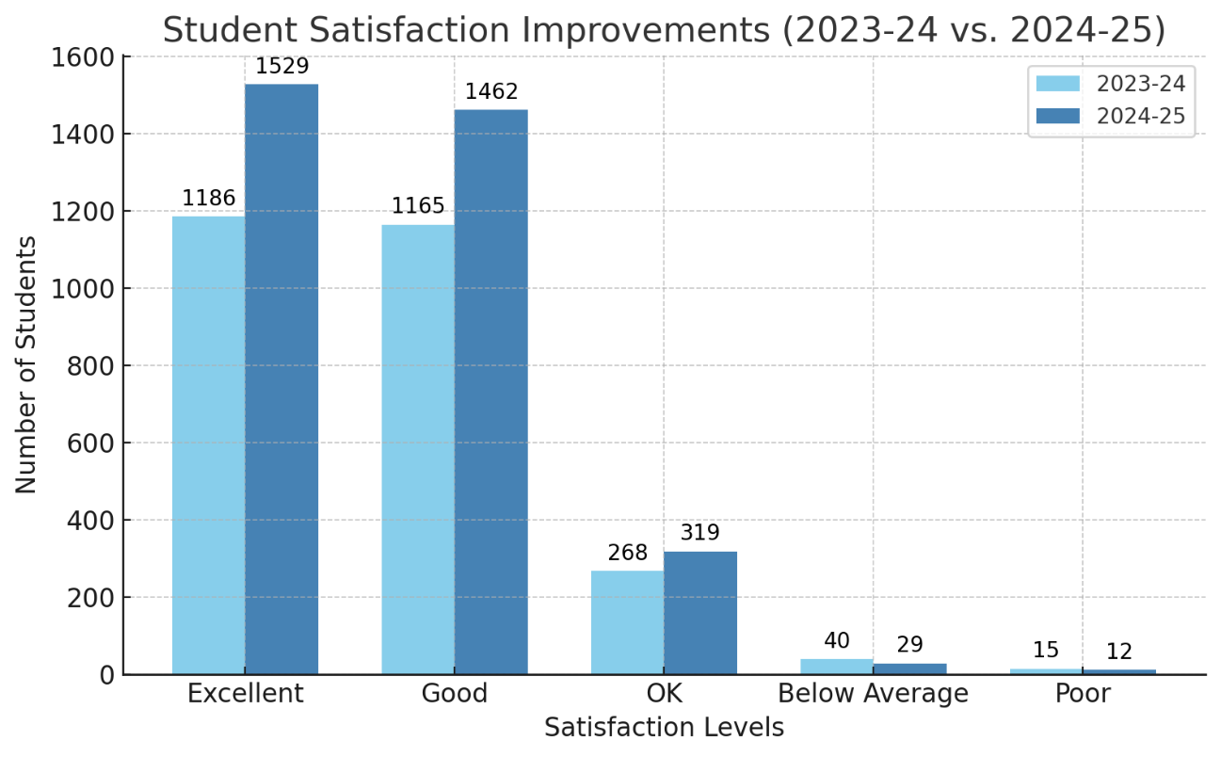

Student Satisfaction with Learning Inclusion

Students with disabilities, some of which are quite complex, can often have additional barriers that leads to an increased chance of withdrawal.

The following graph highlights the positive role that the Learning Inclusion team can play in supporting students to retain their place on their course, it suggests a positive correlation between being supported by Learning Inclusion and a reduced chance of early withdrawal. Over 97% of students who rated the Learning Inclusion service as part of the early impressions survey rated it OK to Excellent.

With over 1400 student respondents, this is a significant sample, who are overwhelmingly positive about the Learning Inclusion team and the support that is provided.

# External Influences

**External Influences on Glasgow Clyde College's Equality Reporting**

**Public Sector Equality Duty (PSED)**

The Public Sector Equality Duty (PSED) consists of a general duty under the Equality Act 2010 and specific duties outlined in The Equality Act 2010 (Specific Duties) (Scotland) Regulations 2012, amended by The Equality Act 2010 (Specific Duties) (Scotland) Amendment Regulations 2016. These duties are designed to assist public bodies in Scotland in meeting the general duty.

**Scottish Government PSED Update**

In March 2025, the Scottish Government, through the Minister for Equalities, Kaukab Stewart MSP, issued an update on the Public Sector Equality Duty (PSED) framework. This update, addressed to stakeholders, outlines significant strides and future plans in advancing equality and human rights across Scotland. Glasgow Clyde College, like other public bodies, is directly influenced by these governmental directives and initiatives, shaping its approach to equality mainstreaming.

**Leadership and Commitment**

The Minister's letter emphasises visible leadership and a shared commitment to equality. This leadership is not only about setting policies but also about active engagement with various equality networks and forums. For us at Glasgow Clyde College, this means aligning our equality mainstreaming report with the government's vision of a fairer and more inclusive Scotland. The college is encouraged to demonstrate its commitment through proactive measures and visible leadership within its community.

**Inclusive Communications**

One of the key updates in the letter is the focus on inclusive communications. We hope to use any new resources to enhance our communication strategies, ensuring that all students and staff, regardless of their backgrounds, can access information and participate fully in college activities. This aligns with the college's goal of fostering an inclusive environment.

**Mainstreaming Strategy and Toolkit**

The letter mentions the development of a new equality and human rights mainstreaming strategy, supported by an action plan and toolkit. We look forward to utilising this toolkit to integrate best practices into our operations. The practical support provided, including guidance, training materials, and checklists, will help us equality objectives and report on its progress effectively.

**Developing Competence**

The Scottish Government's emphasis on developing competence within the public sector is another crucial aspect. The Equality and Human Rights Development Academy, mentioned in the letter, provides opportunities for learning and growth. Glasgow Clyde College can participate in such initiatives to enhance the skills and knowledge of its staff, ensuring that everyone is well-equipped to advance equality and human rights within the college.

**Pay Gap Reporting**

Glasgow Clyde College complies with these regulations, ensuring transparency and accountability in its pay practices. Our [Equal Pay statement and Report 2025 can be found here](https://www.glasgowclyde.ac.uk/assets/000/008/417/Equal_Pay_Gap_2025_original.pdf?1745836190), demonstrating our commitment to addressing pay disparities.

**Scottish Government's Student Mental Health Action Plan**

The Scottish Government's Student Mental Health Action Plan, published in September 2024, aims to enhance student mental health and wellbeing through effective collaborative working across colleges, universities, NHS Boards, Integrated Joint Boards, Public Health Scotland, Health and Social Care Partnerships, and the third sector. This plan emphasises prevention, early detection, and access to appropriate treatment, ensuring that student wellbeing is a core focus.

**Scottish Funding Council (SFC) and Memorandum of Understanding**

The Scottish Funding Council (SFC) continues to play a crucial role in advancing equality within the tertiary education sector. The Memorandum of Understanding (MoU) between the SFC and the Equality and Human Rights Commission (EHRC) strengthens joint working to promote equality for college and university students and staff. The SFC's National Equality Outcomes (NEOs) report, published in January 2025, outlines persistent inequalities in the tertiary system and calls for institutions to address these issues as part of their Public Sector Equality Duty.

**Tackling Persistent Inequalities Together**

The SFC's report, "Tackling Persistent Inequalities Together," published in January 2025, outlines the persistent inequalities in the tertiary education system and asks institutions to address them by contributing to a set of National Equality Outcomes (NEOs) as part of their Public Sector Equality Duty. Glasgow Clyde College will progress its Equality Outcomes in accordance with these new NEOs.

By incorporating these updates and influences, Glasgow Clyde College ensures that this Equality Mainstreaming Report reflects the latest standards and commitments.

# Commitment

Glasgow Clyde College is committed to mainstreaming with due regard to the three general duties and this is evidenced within the following strategies, drivers and initiatives.



One such strategy to enhance our inclusive mainstreaming efforts involves adopting a 'nurture approach' and evolving into a more 'trauma-informed' college. This approach supports mainstreaming equality and the attainment of our Equality Outcomes as we seek to ensure that ‘***Everyone within our Glasgow Clyde College community feels a strong sense of belonging and safety, assured of their ability to thrive within a nurturing and aspirational environment.’***

What is a nurture approach?

• It is a focus on wellbeing and the development of positive relationships

• It supports personal, social and emotional skills development

• It recognises that establishing positive relationships supports learning and development

• It identifies the impact that environmental and external factors can have

• It aims to build resilience and promote growth

Glasgow Clyde College has made significant strides towards becoming a Nurture College with trauma-informed approaches since the formal launch of this initiative at the start of the 2023/24 session. This commitment was fully endorsed by the Senior Leadership Team (SLT) and has been supported through various activities and feedback mechanisms. Further details can be found later in the Progress section.

**External Engagement**

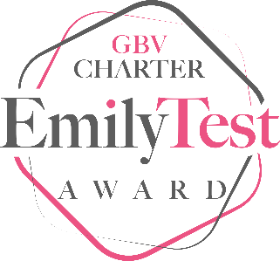

[EmilyTest](https://www.emilytest.org/)

Following on from being a pilot institution in 2021, all of us at Glasgow Clyde College are now extremely proud that we successfully achieved Charter status in January 2025. Our work to prevent and support those affected by gender based violence continues as we attend all relevant surgeries and events. Our Equality & Diversity Lead and Senior People Partner have undertaken the Train the Trainer for LISTEN first responders training and will be rolling this out to staff by August 2025. Further developments are detailed later in the Looking Forward section.

[Fearless Glasgow | Glasgow Caledonian University | Scotland, UK](https://www.gcu.ac.uk/aboutgcu/commongood/fearless-glasgow)

Glasgow Clyde College is a member of Fearless Glasgow, a regional consortium of Glasgow Colleges and Universities which was officially launched in November 2019. The group is a multiagency partnership tackling and preventing gender-based violence in all its forms through joint strategic and operational actions. Primarily focusing on further and higher education settings we are committed to ending gender-based violence by challenging harmful behaviours and attitudes alongside supporting those impacted and building confidence. Informed by [Equally Safe](https://www.gov.scot/Publications/2017/11/5647), the common purpose is to deliver safer communities and culture change; a Fearless Glasgow.

[Strategic Networks/Communities of Practice - College Development Network](https://www.cdn.ac.uk/strategic-networks-communities-practice/)

Glasgow Clyde college is an active member and Co-Chair of CDN’s Equality Diversity & Inclusion Strategic Network, meeting monthly, the network is a collective voice for equality and diversity practitioners and leads in colleges across Scotland: informing sector equality priorities, influencing statutory and sectoral bodies, collaboratively working to embed EDI “in all aspects of further and higher education, making Scotland’s colleges truly inclusive learning environments, workplaces, and community hubs.”

[TransEDU - Community of Practice](https://www.trans.ac.uk/ResourcesInformation/CommunityofPractice/tabid/7259/Default.aspx)

Glasgow Clyde College is a member of transEDU Community of Practice which “brings together staff from colleges and universities across Scotland to share expertise, build knowledge, develop practice, and gain peer support in advancing trans and non-binary equality - and improving experiences of trans and non-binary students and staff - in their institutions.” Through proactive involvement with this group, the college is developing new guidance for staff and students, has promoted the relevant resources and provided training across the organisation.

[The Forum by Think Positive - Think Positive](https://thinkpositive.scot/resources/the-forum-by-think-positive/)

Glasgow Clyde College is a member of the NUS Think Positive Forum. The GCCSA Coordinator and the Mental Health Lead are the joint project leads. We are currently finalising our GCC Student Mental Health & Wellbeing Agreement, which will be launched in June. The Mental Health Lead has been closely involved in negotiating referral pathways to external partners who can provide ongoing mental health support for students whose need for support exceeds what the college provides. These will be in place for the start of the next academic year.

[SCAPP - SCAPP (Scotland’s Community of Access and Participation Practitioners)](https://www.fairaccess.scot/scapp-scotlands-community-of-access-and-participation-practitioners/)

The Student Information & Welfare Manager attends on behalf of the college and hopes to utilise resources and training from this member-led community of practice.

[National Network of Universities and Colleges dedicated to Suicide Prevention - Think Positive](https://thinkpositive.scot/resources/national-network-of-universities-and-colleges-dedicated-to-suicide-prevention/)

Glasgow Clyde college is a member of this new network set up in 2024. The Network is a space for sharing learning and providing peer support across colleagues working in Scotland's universities and colleges as they develop their suicide prevention activities. It facilitates the sharing of national approaches as well feeding into the next stages of the Scottish Government Student Mental Health Action Plan. It shall consider suicide prevention support for both students and staff who have thoughts of taking their own life or are affected by suicide, as well as the diversity of needs, to get the help they need and feel a sense of hope.

**FE & HE Sector British Sign Language Group**

Glasgow Clyde College is a member of the national BSL group for colleges and universities which encourages collaboration, advice and sharing of good practice to progress our work to support BSL users in tertiary education.

**Internal Engagement and Commitment**

**The Equality, Diversity & Inclusion (EDI) Committee**

The EDI Committee is a key component of the College’s governance structure, reporting directly to the Senior Leadership Team (SLT) and playing a crucial role in shaping and supporting the College’s equality, diversity, and inclusion (EDI) agenda. Its remit ensures that staff and students can work and study in an inclusive and progressive environment.

The Committee provides strategic oversight of the College’s equality outcomes, ensuring they align with national equality priorities and legislative requirements. It advocates for EDI initiatives within Glasgow Clyde College and the wider community, combining strategic direction with professional challenge and advice from the College EDI Lead. The Committee also promotes best practices, supporting staff in embedding EDI principles across College services, teaching, and operational delivery.

A key function of the EDI Committee is to monitor compliance with the Equality Act 2010 and other relevant legislation, ensuring that the College meets its statutory obligations. It plays a pivotal role in informing the SLT on EDI developments, identifying priorities, and preparing reports and recommendations that are submitted to the Board of Management Committee as part of the College’s governance protocols. Direct reporting to the College Organisational Development Committee and the Learning and Teaching Committee through the Student Experience update ensures full visibility of EDI work within our governance frameworks. This has been shaped by a presentation and discussion at the Board of Management of EDI work and priorities within the College which has ensured that equality, diversity, and inclusion remain integral to decision-making and continuous improvement across the institution.

**Gender Based Violence Prevention & Support working Group**

In order to maintain our EmilyTest Charter and progress our work to support our community against all aspects of GBV, we will continue with our Working Group. The group will also work beyond the charter to increase awareness of GBV and provide our staff and students with confidence that they can access support should they be impacted upon by GBV.

**Safeguarding & Mental Health First aiders**

New Safeguarding and Mental Health First Aid systems have been developed to ensure that we are able to appropriately triage mental health and safeguarding concerns. Concerns for the mental health of a student are supported by a team of mental health first aiders who are accessible by a helpline. For concerns regarding the immediate safety of a student, the Safeguarding helpline. The specifics of each concern will lead to the MHFA or Safeguarding Officer making a judgement as to how best to support an individual.

During the years 2023 and 2024, the college recorded a total of 143 safeguarding/MHFA incidents. These incidents varied in nature and severity, prompting the need for thorough analysis and responsive measures. Additionally, 89 non-safeguarding incidents were reported, highlighting the importance of maintaining a comprehensive approach to student welfare.

The categorisation of safeguarding incidents revealed significant trends. Almost 78% of the incidents reported were related to mental health issues and suicide ideation. This statistic emphasises the urgent need for enhanced mental health resources and support systems within our college community. Following mental health, 16% of referrals were linked to forms of neglect, while less than 5% were associated with gender-based violence (GBV) and other types of physical assault. These figures reflect critical areas that require continued focus and intervention.

A successful internal audit of Student Welfare – Duty of Care was carried out in February 2025 and is available on the college website. Audit Committee, Agendas, Papers and Minutes

**Health, Safety and Safeguarding (HSS) Committee**

The HSS Committee forms part of the College governance framework and meets 4 times per academic year. The remit of the group is to consider and direct the effective discharge of the legal duties of Health & Safety and Safeguarding within the College. This allows senior staff to report on progress, challenges and development within the key statutory responsibilities that fall within the remit of the Committee.

**Staff Induction**

Equality, Diversity and Inclusion (EDI) and nurture college approach is embedded in the staff induction process. We want to ensure that staff are informed and aware of the colleges’ commitment to EDI from the outset of their employment. We provide mandatory equalities training which every new member completes within the first week of employment. We also include a half hour Edi specific session for all staff at our Welcome Induction day where our EDI Lead meets and speaks with new staff, highlighting our EDI priorities and resources. We continually improve our training materials and the EDI Lead collaborates with Learning and Development to update the induction materials, including the introduction to our Report+Support tool and Nurture College within the EDI induction session.

**New PDP Process**

The staff Personal Development Planning (PDP) process as updated and now has the Equality Outcomes and Public Sector Duties embedded in the process. Staff are asked to reflect upon these two areas when planning their development over the next year which will raise staff awareness of these two areas and allow staff and managers to consider their impact when coordinating their goals for the year.

**Report+Support**

[Report and Support | Glasgow Clyde College](https://www.glasgowclyde.ac.uk/study-at-glasgow-clyde/report-and-support)

Working in partnership with Culture Shift, the Report and Support tool was implemented at the start of 2022 and was introduced with a soft launch by hosting information on the College website and promoted engagement with the platform through College and GCCSA social media activity. It is now available from the main page of the college website, on Canvas (our virtual learning environment) and the staff intranet. It has been included within staff and student inductions.

Our online tool enables students and staff to report incidents of gender-based violence, racial harassment, hate crimes and other forms of inappropriate behaviour. It builds on a range of resources we’ve put in place to prevent and respond to various issues, including our Safeguarding Team who are on-hand to help anyone affected by gender based violence, harassment or abuse. The reports can be made by any member of our college community and can be reported by name or anonymously. Limitations of anonymous reporting are fully explained on the platform and every report is directed through the appropriate College procedure, e.g. safeguarding, complaints, disciplinary, etc. It is designed to provide confidence that any reports will be taken seriously and followed up as per the appropriate College procedure and system. By doing so, a central reporting and recording system with in-built analytics, automated case management protocols and contextualised support resources and signposting are available to our entire college community.

**Learning Inclusion**

The Learning Inclusion Team provide learning support to those who face additional barriers to their learning. [Learning Inclusion | Glasgow Clyde College](https://www.glasgowclyde.ac.uk/study-at-glasgow-clyde/student-support/learning-inclusion)

Student retention requires a whole-college approach, where every aspect of the institution, academic departments, student services, administrative units, and campus life, collaborates to create a supportive and inclusive environment.

Students with disabilities, some of which are quite complex, can often have additional barriers that leads to an increased chance of withdrawal.

The data below highlights the positive role that the Learning Inclusion team can play in supporting students to retain their place on their course, it suggests a positive correlation between being supported by Learning Inclusion and a reduced chance of early withdrawal.

Further withdrawal overall is slightly higher than the college average however, when we delve into this data in more detail, it highlights that for both HE and FE full time students, those in receipt of Learning Support are less likely to withdraw.

|  |  |  |
| --- | --- | --- |
| **Full Time 2023/24** | **College Average** | **Learning Inclusion Supported** |
| **HE** | 15.3% | 10.7% |
| **FE** | 16.8% | 14% |

Scrutinisation of data will enable us to better understand the courses, levels, disabilities etc. that are finding it more challenging to successfully complete their studies, as well as any patterns or trends for those that are managing to successfully achieve.

We believe that enhanced communication and collaboration between the Learning Inclusion team and lecturing staff will help to create an environment that can lead to increased student retention and attainment.

**Breakfast Club**

Glasgow Clyde College launched a breakfast club for students across all three of its campuses in a bid to tackle food poverty and the cost of living crisis.

Each of our 15,700 students are entitled to toast/cereal and a hot drink between 8.15am – 9.15am.

[Glasgow Clyde College launches free breakfasts for students | Glasgow Clyde College](https://www.glasgowclyde.ac.uk/news/934-glasgow-clyde-college-launches-free-breakfasts-for-students)

The numbers for the breakfast items served are as follows:

AY21/22: 1,638 (trial period from April 22 to June 22)

AY22/23: 42,361

AY23/24: 41,861

AY24/25: 21,742 (up to 17th January 25)

The total items served over the Breakfast Club is 107,602. On average, students take two items, therefore approximately 53,801 students have benefited from the Breakfast Club since we launched. We are delighted to have secured funding to continue this initiative over the next 3 academic sessions.

**Mental Health Lead Post**

Our Mental Health Lead has undertaken a fundamental analysis of our provision and has developed a new strategic approach to student health and wellbeing. The new approach is underpinned by the Student Mental Health Agreement (SMHA) which we are finalising in partnership with GCCSA and Think Positive NUS.

Core to the development is an online course called ‘Stay Well and Thrive at Glasgow Clyde College’ which seeks to educate and support students regarding health and wellbeing and the links to their mental health. The emphasis is upon what an individual can do to stay well rather than focusing upon the reactive services that may support por mental health or mental illness.

Our Mental Health Lead has been successfully piloting delivery of this course in partnership with lecturing staff with 3 curriculum areas and is currently doing a roadshow with wider Faculty and Support areas to promote the new approach and resources. A full communication plan will integrate our new approach with the SMHA and will be rolled out from May 2025.

Reactive support is still provided by our Student Information and Welfare team,

Mental health First Aiders and Safeguarding teams as well as the pastoral support from lecturing staff. However, we have developed a network of external referral pathways to ensure that students can access to most appropriate service provision including counselling, primary healthcare and other primary and third-sector support services that have the expertise and resources to fully support vulnerable learners.

**Active Campus Coordinator Post**

The SportScotland funded project to provide an Active Campus Coordinator has been a resounding success and evidence of a variety of activities is included later in the Progress section. The funding has now been extended for a further 2 years which will take the project through until approximately June 2027. This post has seen many activities take place across our 3 campuses and fostered collaboration and engagement from diverse student groups. Examples of these activities and projects can be found in the next section under Progress.

# Progress

We have developed and progressed many areas to mainstream equality, diversity and inclusion alongside our commitments.

In order to underline our progress in mainstreaming, please see following specific examples from across the College.

These examples include a key to highlight the relevant PSED General Duties.

**E**liminate unlawful discrimination, harassment and victimisation and other conduct prohibited by the Act

**A**dvance equality of opportunity between people who share a relevant protected characteristic and those who do not

**F**oster good relations between people who share a protected characteristic and those who do not.

**Nurture College E, A, F**

The journey towards embedding a nurture approach began with SLT participating in a training workshop during the 2022/23 session to develop a comprehensive understanding of the nurture approach and the commitment required. Following this, a survey conducted by the Organisational Development (OD) team across the college revealed a positive response from 17 teams, which informed the creation of a Nurture Action Plan.

Bespoke materials for staff and students were developed and made available online through Canvas and the OD portal. These resources, including information slides, activities, and links to additional materials, have been updated based on internal feedback to ensure relevance and effectiveness.

A Teams group for staff has grown to 124 members, facilitating the sharing of resources, information, and development opportunities. Additionally, a Steering Group was established in 2023/24, comprising 27 members, including representation from GCCSA. This group has held four meetings and is actively progressing 16 of the 19 actions outlined in the Nurture Action Plan.

The college has also engaged in the College Development Network’s Trauma-Informed College programme, with 60 staff attending an introductory session. A bespoke two-day training programme by the Glasgow City Council Nurture Team further supported the development of the nurture approach, benefiting 20 college leaders.

In-house training sessions, including face-to-face and online formats, have been offered to various staff groups, ensuring widespread understanding and implementation of the nurture principles. These sessions have reached OD and HR teams, finance and student funding staff, support staff, curriculum support assistants, faculty staff, and more.

Numerous activities and events have been organised across the college, featuring contributions from external experts and organisations. These include collaborative problem-solving sessions, conferences on ‘Keeping the Promise’ focusing on how we support those with care experience, discussions on trauma's impact on the brain, and events celebrating diversity and supporting mental wellbeing.

External connections have been strengthened through contributions to the Scottish government's Equally Safe strategy and participation in conferences and workshops. Bespoke workshops for specific student groups have been supported by organisations such as Brothers in Arms and the Scottish Violence Reduction Unit.

The Nurture Action Plan continues to guide the college's efforts, with progress on 16 of the 19 actions on track for completion by June 2025.

Online training and materials have been updated for the 2024/25 session, ensuring

ongoing support for staff and students.

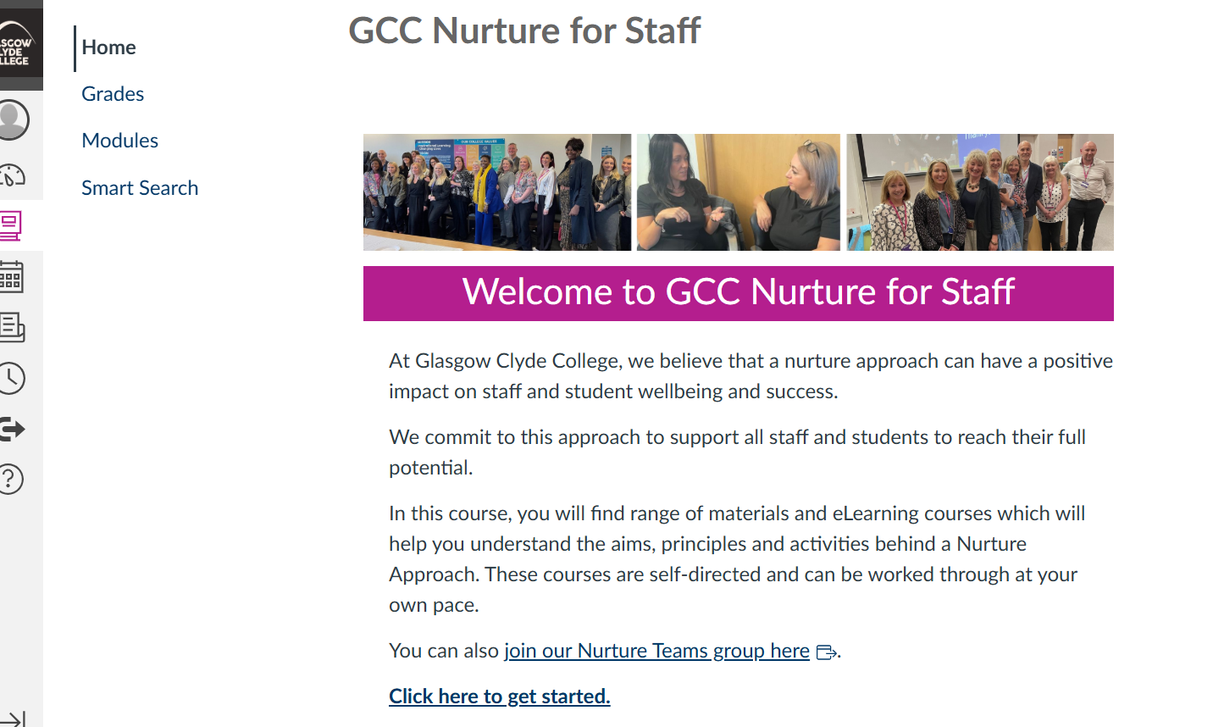

Glasgow Clyde College's commitment to becoming a Nurture College with trauma-informed approaches is evident in the positive feedback and engagement from staff and students. We look forward to continuing this journey and reporting on our progress in the coming years.

**Stay Well & Thrive E, A, F**

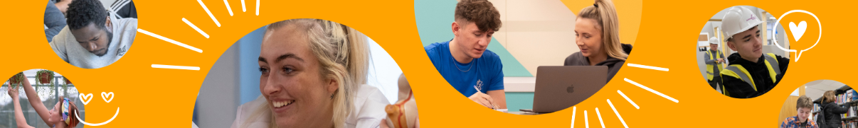

The Scottish Government has provided significant funds to Scottish Colleges and Universities since the pandemic with a primary focus upon the provision of Student Counselling. This funding stream has now ended and in the absence of a ring-fenced funding stream, the College has developed a new strategic approach in an attempt to move the focus away from reactive support for poor mental health toward a proactive approach to promote positive health and wellbeing.

Our priority is to provide high quality teaching and learning to our students and community and to ensure that we provide appropriate support to facilitate that service. We are not resourced to provide primary care health services and have attempted to reflect that in our new approach.

**Why ‘Stay Well & Thrive’ at Glasgow Clyde College?**

At Glasgow Clyde College we’re committed to providing a positive and nurturing environment where everyone feels safe, valued and motivated to achieve their full potential. Our inclusive and proactive approach to supporting students’ mental health and wellbeing stems from the understanding that it benefits every student to have continuous access to resources which focus on how to ‘stay well and thrive’ at college.

**What is mental health?**

In many ways, mental health is just like physical health. We all have it and we all need to take care of it, because it won't take care of itself. The state of our mental health affects how we think, feel and react on a day-to-day basis. It determines how well we cope with life's challenges and has a significant impact on our ability to experience joy and to recover from setbacks or difficulties.

**Understanding mental health and wellbeing**

The language around mental health can be confusing, especially since varying terminology is used in different settings. It is important to understand that ‘mental health’ is not a byword for ‘mental illness’. Most people who show occasional signs of anxiety, stress, irritability or low mood are not mentally ill - they are experiencing the symptoms of depleted mental wellbeing. Depleted mental wellbeing is often a consequence of neglecting one's mental health or not knowing how to look after it.

**Our ‘Stay Well & Thrive’ model**

Our ‘Stay Well & Thrive’ model is evidence based and shows that almost everyone can take steps to improve their mental wellbeing, even if they have a diagnosed condition affecting their mental health. The Mental Health Continuum clearly illustrates this point.

The horizontal axis of the continuum as “the water line” and the vertical axis is described by our Mental Health Lead Alison Cox as “the slippery pole”.  The true indicator of a mentally healthy, inclusive college community is one in which everyone is encouraged, equipped and supported to stay in the upper zones of the Mental Health Continuum (well above the water line).

The ‘Stay Well & Thrive’ online course introduces the eight elements of wellbeing including diet, exercise, sleep, digital detox etc and provides practical advice on how to stay well by making small changes and adopting these good wellbeing habits in order to be ‘the best version of ourselves’ at college and elsewhere.



It will be included as part of inductions from August 2025.

**Male Mental Health and Suicide Prevention with** [**Brothers In Arms**](https://www.brothersinarmsscotland.co.uk/) **E, A**

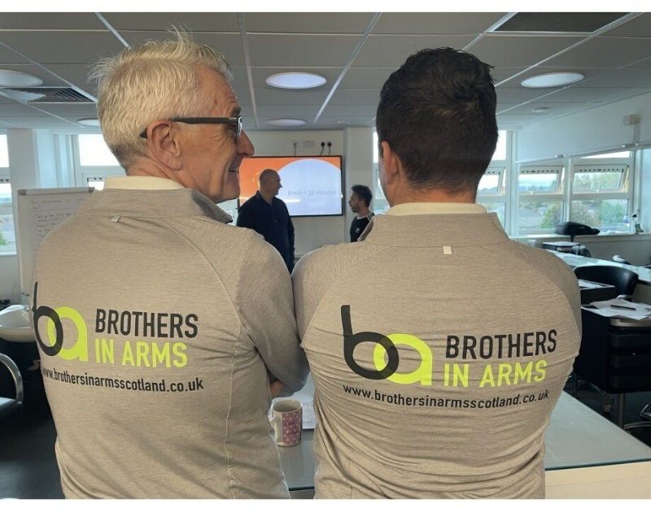

Glasgow Clyde College (GCC) has teamed up with the Scottish Violence Reduction Unit (SVRU) and men’s mental health platform Brothers in Arms in a mission to support those suffering with poor mental health, which began from the comfort of a hair salon chair.

A partnership with the charity Brothers in Arms and The Scottish Violence Reduction Unit has resulted in a new course ‘Promoting Positive Mental Health and Suicide Prevention’ to support students who will work with clients on a 1-1 basis whilst on placement. [Supporting mental health conversations through unique partnership | Glasgow Clyde College](https://www.glasgowclyde.ac.uk/news/1062-supporting-mental-health-conversations-through-unique-partnership)

Bespoke workshops for Hairdressing/Barber, Sports Coaching and Personal Trainer and Construction students and staff have now all taken place supported by Brothers in Arms, The Scottish Violence Reduction Unit and Strathclyde University.

“Reaching in conversations” training course aimed at tackling male mental health stigma, was credit-rated at SCQF Level 5 and highlighted the versatility of SCQF rating in addressing diverse educational needs.

[Innovative male mental health training at SCQF level 5 – Scottish Credit and Qualifications Framework](https://scqf.org.uk/news-and-blog/breaking-the-stigma-scqf-level-5-qualification-tackles-male-mental-health/)

**New Self Evaluation process- embedding Equality Outcomes E,A,F**

A new Quality Framework has been applied to Scottish Colleges and Universities. QAA have developed a new framework and sessions 2024/25 has seen the first submission of the College Self-Evaluation Action Plan (SEAP), the implementation of an Internal-

Led Quality Review (ILQR) process and the development of a system of quality assurance including stakeholder feedback, self-evaluation and deep-dive analysis.

The process has been designed to ensure that EDI information and development lies at the heart of self-evaluation. The new College Equality Outcomes are embedded in the Curriculum and Support Self-Evaluation processes and reporting on the 3 primary equality duties in relation to the Protected Characteristics of students will be analysed to highlight best practice, challenges and developmental opportunities.

**Menopause Friendly Employer E, A**

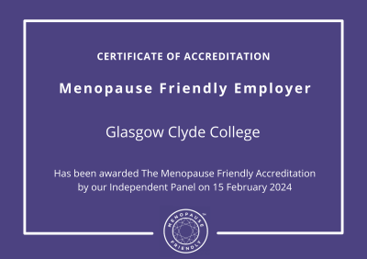

Achieving **Menopause Friendly Accreditation** in February 2024 is a major milestone in the College journey toward creating a more inclusive and supportive workplace. This accreditation reflects the meaningful steps the College have taken to ensure that menopause is recognised, understood and supported across the College. Through education, open conversations, and tangible workplace adjustments, we are fostering an environment where colleagues feel valued and empowered, no matter what stage of life they are in.

[Glasgow Clyde College is awarded the Menopause Friendly Accreditation](https://www.glasgowclyde.ac.uk/news/1099-glasgow-clyde-college-is-awarded-the-menopause-friendly-accreditation)

A key part of this achievement has been the introduction of our Menopause Policy, which sets out clear guidance on the support available to staff experiencing menopause. This policy ensures that everyone has access to the adjustments they may need, whether that’s flexible working arrangements, access to quiet spaces, or simply fostering a culture where conversations about menopause are normalised. By embedding this policy into our workplace framework, the College are demonstrating our long-term commitment to creating a menopause-friendly environment.

Additionally, we have implemented Gender-Sensitive Risk Assessments, recognising that menopause symptoms can be exacerbated by certain working conditions. These assessments help identify any workplace factors, such as temperature control, uniform requirements or high-stress environments that may impact staff who are experiencing menopause. By proactively addressing these risks, we are making sure that our workplace is comfortable and supportive for all.

One of the most successful initiatives that contributed to our accreditation has been our Menopause Café which currently has 58 members. These informal, welcoming sessions have provided a safe space for colleagues to share experiences, ask questions and support one another. The positive response has been overwhelming, with many attendees highlighting how valuable it is to have open and stigma-free conversations. The success of these Menopause Cafés has reinforced the importance of ongoing dialogue and peer support.

We aligned our menopause-friendly efforts with World Menopause Day (October 18th) and International Women’s Day (March 8th) in 2024-2025. These global events provide the perfect platform to celebrate our achievements, promote awareness and encourage more colleagues to engage in menopause conversations. To mark these occasions, we have held special Menopause Café sessions and organised events to continue the conversation and highlight the importance of workplace support.

We have continuous training in place for managers to ensure they can support staff who are experiencing menopause. This ongoing training helps managers understand challenges, provide workplace adjustments and foster an inclusive culture.

Achieving Menopause Friendly Accreditation is just the beginning. With our Menopause Policy, Gender Risk Assessments, and thriving Menopause Cafés, we are committed to ongoing progress. By continuing to educate, support and listen to our staff, we are ensuring that menopause is not just acknowledged but actively supported in the workplace.

**EmilyTest Charter Status E, A**

“We are delighted that Glasgow Clyde College has achieved the EmilyTest GBV Charter Award, a well-deserved recognition of their strong commitment to addressing Gender Based Violence. GCC exemplifies how a whole-college approach can drive meaningful change, and they have consistently demonstrated their dedication at every level. The college's efforts give students the best chance to live, work, and study free from the harms and threats of Gender-Based Violence (GBV), sending a strong message of support to students and staff while serving as a powerful example for other colleges and universities to follow.” *Fiona Drouet EmilyTest CEO*

[Glasgow Clyde achieves the EmilyTest GBV Charter | Glasgow Clyde College](https://www.glasgowclyde.ac.uk/news/1167-glasgow-clyde-achieves-the-emilytest-gbv-charter#:~:text=Glasgow%20Clyde%20College%27s%20(GCC)%20work,achieving%20the%20EmilyTest%20GBV%20Charter.)

**White Ribbon Scotland E, A**

Since achieving White Ribbon Status in 2020, the college and GCCSA team are committed to a range of activities going forward to ensure that we have a safe community for staff and students. This includes annual support and attendance in Glasgow Central station to raise awareness. In November 2023 Glasgow Clyde College students have created a series of artwork in partnership with charity White Ribbon Scotland, with the aim of raising awareness of abusive behaviour towards women. The artwork, which has been created by media and photography students, displays compelling photography, graphic design and poetry, inspired by real stories of domestic violence.

Unveiled at Glasgow Central Station during the 16 Days of Activism - an international campaign launched in 1991 with the goal of ending gender-based violence - the college aims to work with ScotRail on a longer-term campaign that will see the students’ artwork being installed across city centre train stations, to continue to raise awareness of an issue that is faced by thousands across the country.

[Students create bespoke artwork to support White Ribbon Scotland | Glasgow Clyde College](https://www.glasgowclyde.ac.uk/news/1070-students-create-bespoke-artwork-to-support-white-ribbon-scotland)

**Student Support Officers E, A, F**

The role of the two new Student Support Officers in the Faculty of Arts & Continuing Learning is to provide support and guidance to students facing barriers to their education. The Faculty offers access routes into learning and employment including ESOL (English for Speakers of Other Languages), Dance, Performing Arts, Adult Literacy and Numeracy, Return to Study courses, the Princes Trust Team programme and Employability as well as courses for Learners with Additional Support Needs. The purpose of the role is to ensure students can sustain, successfully complete and progress from their courses into positive destinations. The role involves identifying students' needs, providing guidance and assistance and collaborating with other departments, external agencies and employers to remove obstacles to learning and enable successful progression.

**Action for Children – STAY E, A**

Initially, as part of the Glasgow Colleges regional Board (GCRB) Plan of Action and a complementary activity funded by the Robertson Trust, the 3 Glasgow Colleges have now agreed to continue to partner with Action for Children in order to support young people transition and study at college until June 2026. Activity has primarily focused upon care experienced learners and as a College, we now have approximately 900 who have disclosed as care experienced with Action for Children working with almost 80 of the most vulnerable learners within the College.

The focus has expanded to include other categories of vulnerable learners including carers and those from SIMD 10 areas. Part of the programme has focused upon the transition of vulnerable young people from school to college and this has seen a significant development of the links between the School Liaison Team with the College, our local authority partners and Action for Children. Much of the focused work has seen significant interventions and support in relation to funding, welfare and access to primary care services. Read more about [STAY](https://www.glasgowclyde.ac.uk/assets/000/007/327/STAY_Flyer_original.pdf?1681823853)

**GCCSA Student Modules E, A**

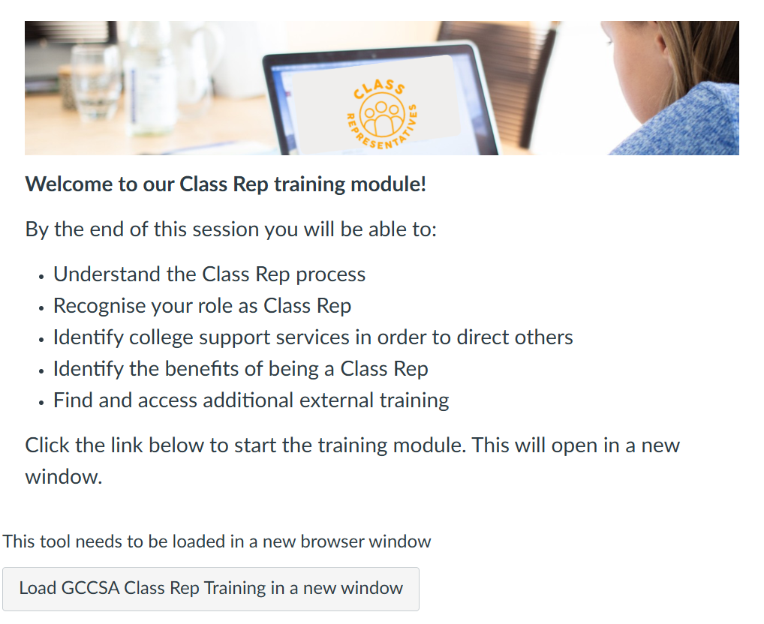

In the academic year 2024/2025, Glasgow Clyde College (GCC) introduced two new student modules aimed at enhancing the student experience and support mechanisms. These modules are part of the ongoing efforts to mainstream equality and ensure comprehensive support for all students.

My Student Experience Dashboard

The "My Student Experience" area is now included on the dashboard of all students. This area provides easily accessible information on various support services, ensuring that students have the resources they need at their fingertips. Key features include:

* Health and Wellbeing Section: This section offers detailed information on both internal and external support services. It includes the "How to Stay Well and Thrive at GCC" module, which provides guidance on maintaining mental and physical wellbeing.
* Student Association Area: This area includes information on student activities and campaigns, as well as the new Class Rep training modules developed by the GCC Student Association (GCCSA).

Student Modules

GCCSA has collaborated with the college's E-learning Team to develop two essential modules:

1. **Get to Know Your Student Association**: This module introduces students to the activities, campaigns, and support services offered by the Student Association.
2. **Internal Class Rep Training**: This module is specifically designed for student class representatives and was completed in the 2024/2025 academic year. It aims to equip Class Reps with the knowledge needed to support their peers effectively.

The Class Rep training module includes references to support available for students, including guidance on topics such as gender based violence (GBV). The purpose of this training is to ensure that Class Reps are well-informed about the support services available at the college. This knowledge is crucial for Class Reps to guide their peers to appropriate resources if they or their classmates need support.

During the development of these training sessions, GCCSA sought approval from other student experience support areas to ensure comprehensive coverage of wellbeing and equality topics. The Equality & Diversity Lead ensured that the modules included relevant information on wellbeing and equality, with specific references to GBV support.

The "Get to Know Your Student Association" module is shared with all students, while the “Class Rep” module is distributed to all student class representatives. The training aims to empower Class Reps with the necessary information to support their peers, adding another layer of support within the student community. This initiative recognises that students may feel more comfortable discussing issues with their fellow students, and Class Reps can play a pivotal role in directing them to appropriate college services.

By integrating these modules into the student experience, the college continues to demonstrate its commitment to equality, wellbeing, and comprehensive support for all students.

**Active Campus Coordinator Activities E,A,F**

**ESOL football**

In January 2024, Glasgow Clyde College established an ESOL-specific football team at the Langside campus, coached by one of the ESOL lecturers. This initiative was launched due to the lack of access to football pitches and opportunities for free football practice on campus and in local areas. Initially, the team comprised 6-8 ESOL students participating in weekly practices. To generate more interest, the concept of cross-college friendly games was introduced.

This idea gained traction, leading to the formation of ESOL football teams at other colleges, thereby facilitating cross-campus games specifically for ESOL students. These games provide students with the opportunity to practice English in a non-traditional classroom setting and foster a sense of community, with friendships forming among students with shared experiences.

The first match took place against Glasgow Kelvin College in March 2024, with over 16 students participating and additional students attending to support their classmates. All attendees were ESOL students.

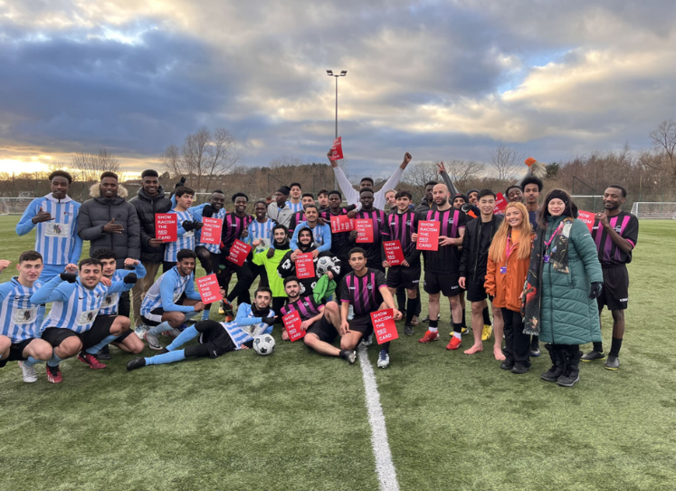

Since then, there have been four additional matches, with the team growing each time. Notably, a match in March 2025 between ESOL Clyde and Glasgow Kelvin College was held in support of the "Show Racism the Red Card" campaign.

Plans are underway for a larger-scale event in April 2025, involving five colleges across Scotland in the first-ever cross-college ESOL football tournament.

**Boccia**

Since February 2024, boccia has been integrated into various aspects of learning and one-off activities at Glasgow Clyde College. Boccia is a versatile sport that accommodates individuals with a range of physical disabilities and is featured in the Paralympics, making it an excellent inclusion for student engagement.

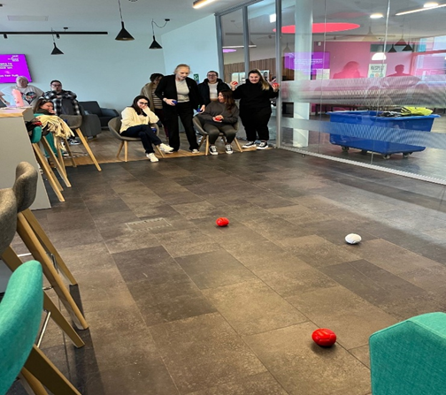

The sport has been utilised in team-building sessions, lunchtime drop-in sessions, events, and classroom break activities. Throughout the 2023-2024 period, there have been 21 boccia sessions with a total of 198 participants. The participants included both male and female students, with 15 sessions specifically designed for supported education students.

**Game Together**

The "Game Together" event, held in September 2024, saw the participation of 330 students over three days across all three campuses. Students from various departments, including Child Care, Computing, EVIP, and Nat 5s, took part. This initiative was introduced at the start of the academic year as a team-building exercise to help students build relationships.

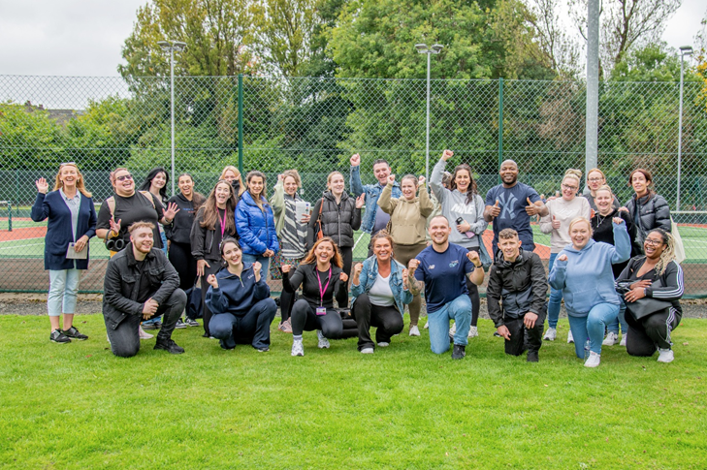

The event featured a range of activities such as badminton, bowls, karate, athletics, cricket, tennis, table tennis, and races. It was coordinated in collaboration with Glasgow Life and the Langside Sports Hub.

The event received excellent feedback and engagement, particularly from students who had not previously participated in any type of activity.

**Centralised College Careers Service E, A**



**The College Careers Service-**

* Supports all students with career planning, development, and employability.
* Offers individual guidance, job search support, employer links, CV writing, job applications, and interview skills.
* Collaborates with Skills Development Scotland (SDS) and other agencies to support vulnerable and disadvantaged students.
* Engages with internal college services like Curriculum teams, Learning Inclusion, and Student Information and Welfare.

**Delivery Model**

* Provides a hybrid model of delivery: in-person across three campuses, remotely via MS Teams, or by telephone.
* Offers tailored support considering the unique needs of each student including disabled students or those from underrepresented groups.
* Manages the CIAG partnership with SDS, referring students for additional support when needed.

**Digital Resources**

* Maintains a dedicated section on the college Canvas VLE with Career Information Advice and Guidance (CIAG) resources.
* Includes job search tools, job opportunity awareness, and an online booking form for appointments.
* Resources are accessible via Immersive Reader and available in multiple languages.

**Supporting University Applications**

* Assists nearly 800 students annually with university applications through the UCAS process.
* Provides cross-campus information events and bespoke support resources.
* Offers links to university specialist teams for care-experienced, refugee, and asylum seeker applicants.
* Achieves an acceptance offer rate of around 83% for students.

# Staff Monitoring and Data Analysis

Recruitment Equality and Diversity Statistics

Applicants – Sex (gender)

Glasgow Clyde College remains dedicated to fostering equality, diversity, and inclusion across all aspects of our recruitment process. To ensure fairness and impartiality, our hiring practices are designed to minimise unconscious bias. We actively monitor the diversity of job applicants to uphold equal opportunities and support a more inclusive workforce. As part of this commitment, equality monitoring information is collected from all applicants at various stages, from initial application through to appointment. External candidates are required to complete an equality monitoring form, which is not used during the shortlisting process. These forms are securely stored and accessible only to HR personnel. The data below reflects both internal and external recruitment activities conducted by the College between February 2023 and January 2025, during which 154 positions were advertised, attracting a total of 5,865 applications. The following breakdown provides insight into applicants by protected characteristic.

Of the 5,865 applicants, 3,495 were female, 2,262 were male and 108 preferred not to disclose their gender.

Applicant – Disability

Of the 5,865 applicants, 477 indicated they had a disability.

Applicant – Ethnicity

Most applications, 73%, have come from people who have described their ethnicity as White. 23% of applicants identify from BAME with the remaining 4% who preferred not to provide any ethnicity information.

The recruitment data reveals that the majority of applicants, 73%, identified their ethnicity as White or White Scottish. This aligns with broader national demographics, as Scotland remains predominantly White Scottish.

Within this group, 1.86% classified themselves as belonging to 'any other White background,' which may include individuals from Eastern Europe and other parts of the UK. This segment represents a diverse range of cultural backgrounds, each bringing unique experiences and perspectives that contribute to a more dynamic workplace.

Excluding the 4% of applicants who chose not to disclose their ethnicity, 23% identified as belonging to non-White ethnic groups, including Asian, Black, Mixed Ethnicity, and other backgrounds. This reflects an increasing level of diversity within Scotland’s population. The growing representation of non-White applicants reinforces the importance of fostering an inclusive workplace where all backgrounds and perspectives are valued.

As an organisation committed to equality, we acknowledge this trend and remain dedicated to ensuring that our recruitment processes are inclusive, welcoming, and accessible to all, regardless of ethnicity or cultural background. Overall, the data highlights a diverse applicant pool, with a strong representation of White Scottish individuals, alongside applicants from other White and non-White ethnic backgrounds.

Applicant – Religion

The recruitment figures for applicants reveal interesting insights into the religious beliefs of the candidates. Out of a total of 5,865 applicants, 1,700 applicants have disclosed that they have no religious belief, making it the highest category in this area. Similar to our current staff, the second-highest category is Roman Catholic, with 949 applicants disclosing this, followed by Protestant with 592 applicants.

604 applicants preferred not to disclose their religious affiliation, which could indicate a growing trend towards non-disclosure in the workplace. This trend may be attributed to a desire to keep personal beliefs private, avoid discrimination or stigmatisation, or simply a preference to keep personal information confidential.

The remaining 2,020 applicants identified with other religions, which could include but are not limited to, Islam, Sikhism, Judaism, and Hinduism. It is worth noting that this category of applicants is diverse and represents a range of religious beliefs and practices.

The high number of applicants with no religious belief highlights a growing trend of secularism in Scotland, where an increasing number of people identify as non-religious or atheists.

Overall, the recruitment figures indicate a diverse pool of applicants with varying religious beliefs, including a significant proportion with no religious affiliation. Employers should take note of this diversity and strive to create a workplace culture that is inclusive and respectful of all beliefs and values.

Applicant – Sexual Orientation

4,741 applicants identified as heterosexual/straight, making it the highest category in this area. A significant number of applicants, 534 in total, preferred not to disclose their sexual orientation, which could indicate a growing trend towards non-disclosure in the workplace.

The remaining applicants identified as non-heterosexual orientations. 132 applicants identified as gay men, 364 applicants identified as bisexual, and 94 applicants identified as gay women. It is worth noting that this category of applicants is diverse and represents a range of sexual orientations and identities.

The high number of applicants identifying as heterosexual/straight highlights the dominant sexual orientation in the recruitment pool. However, the significant proportion of applicants identifying as non-heterosexual orientations indicates the importance of creating a welcoming and inclusive workplace that values diversity and promotes equality.

It is also noteworthy that a significant proportion of applicants, 534 in total, preferred not to disclose their sexual orientation, which could indicate a reluctance to disclose personal information in the workplace. As employers, we respect the decision of these applicants and continue to create an environment where employees feel comfortable sharing personal information only if they wish to do so.

Overall, the recruitment figures indicate a diverse pool of applicants with varying sexual orientations, including a significant proportion of heterosexual/straight applicants, followed by those who identified as non-heterosexual orientations.

Applicants – Age Groups

The recruitment figures provide insights on the age distribution of candidates. Most applicants (2,442) fall within the age range of 21 to 30. Followed by the 31 to 40 age group (1,577). The smallest age group is under 21, with only 137 applicants.

76 applicants did not disclose their age at application stage.

It is interesting to note that the age distribution is relatively evenly spread out across the different age bands, except for the under 21 age group, which has the lowest number of applicants. The data also shows a similar percentage of applicants in the over 60’s age group, previous report 3.09%.

**Appointments**

New starts – Age

During the period there were 245 new starts, 159 female and 86 male employees.

New starts – Sex, Category and Basis

During the report period, there were 245 new members of staff.

62.45% of these were support staff, 35.73% were Lecturing staff with 0.82% in senior management.

Part time new starts made up 73.47% of positions, leaving 26.53% fulltime positions.

The highest percentage (43.27%) is seen in female new starts within support positions, followed by 21.63% of females in lecturing positions.

New Starts – Ethnicity

Unsurprisingly given the local demographic, 79% of new staff to the college identified as; White, White English, White Irish, White other or White Scottish. 12% preferred not to disclose their ethnicity leaving 9% in the BAME groups.

New Starts – Disabilities

76% of new staff to the college have advised that they do not have a disability, followed by 18% who preferred not to answer this question and 6% who advised the do have a disability.

New Starts – Sexual Orientation

The majority, 78% of new staff have identified as being heterosexual/straight. The prefer not to say and those who left the question blank, make up 14%. Leaving 8% of gay man, gay woman/lesbian and bi-sexual staff.

Continuous Professional Development (CPD) January 2023 to February 2025

**Disability**

5.25 % of our overall staffing during this period reported as having a disability. 75.76% of these staff participated in CPD.

**Sex**

During this period 63.77% of our staff were female and of that 73.91% participated in CPD. This contrasts with a participation rate of 62.03% from our male staff.

**Race**

71.28% of our staff of white ethnicity participated in CPD while only 64.81% of staff reporting to be of ‘other’ ethnic origins participated.

**Sexual Orientation**

The levels of Gay Men and Gay Woman/Lesbians participating in CPD is lower than those of both Heterosexual and Bisexual orientation.

**Age**

Participation in CPD for those in the 66-75 age group is very low at only 34.72%. Another age group that is reasonably low on CPD uptake, is the 16-25s sitting at only 50%.

From this summary there are no significant variances amongst different groups participating in CPD at the College, however, we will look further and investigate our course topics to try to identify more courses that would appeal to those in the 66-75 and 16-25 age groups, male staff, our gay colleagues and those from a non-white background.

**Leavers**

Over the 12 months between 15th February 2024 and 14th February 2025, the college saw 158 staff leave the organisation.

The highest reason category for leaving was ‘End of temporary contract’ by 71 employees. The next highest category was ‘Resignation which included 41 employees.

The highest percentages of leavers from lecturing roles were, 28.48% for ‘end of temporary contract’, followed by 10.13% for ‘Voluntary severance’. The highest percentages of leavers from support roles where, 18.35% for ‘resignation’ and 16.46% for ‘end of temporary contract’.

Arts and Continuing Education have the highest number of leavers, 55.26% of this numbers is due to ‘end of temporary contract’ leavers and 10.53% from ‘voluntary severance’.

6.96% of leavers in the past year had declared a disability. 19.62% had failed to disclose either way.

The majority of leavers (74.68%) identified as being heterosexual/straight, 17.09% left chose prefer not to say when asked about their sexual orientation. Leaving 8.23% in the gay man, gay woman and Bi-sexual groupings.

The ethnicity of leavers is highest in ‘White Scottish’ 63.92%, which correlates with the college demographic. The next highest figure, 8.23% comes from staff who did not disclose their ethnicity. There does not appear to be any cause of concern in relation to these figures.

# College Board of Management Information

It is the Policy of the Board of Management to:

· promote and embed the principles of equity and equality in all College services and in every aspect of College life by encouraging, developing and maintaining an ethos which embraces difference and diversity and respects the dignity and rights of all.

The Glasgow Clyde College Board of Management are required to comply with the Glasgow Clyde College Code of Conduct, which includes the following commitments:

· I will treat everyone with courtesy and respect. This includes in person, in writing, at meetings, when I am online and when I am using social media

· I will not discriminate unlawfully on the basis of race, age, sex, sexual orientation, gender reassignment, disability, religion or belief, marital status or pregnancy/maternity; I will advance equality of opportunity and seek to foster good relations between different people.

The Board of Management of Colleges in Scotland is comprised of the following positions:

· 1 x Principal and CEO

· 1 x Chair (appointment by the Regional Board for 4 years)

· 1 x Vice-Chair (appointed by the Board of Management)

· 1 x Senior Independent Member (appointed by the Board of Management)

· 2 x Student Members (elected)

· 2 x Staff Members (elected)

· 2 x Trade Union Members (elected)

· 13 x Non-Executive Directors (including the Chair, Vice-Chair and the Senior Independent Member) (following formal recruitment and selection and subject to Regional Board appointment for up to 4 years).

At the time of writing (February 2025) there are 20 members of the Glasgow Clyde College Board of Management, 9 male and 11 female.

The Board Development Plan 2024/25 sets out actions for the Board of Management for the development of the work of the Board. Action 4 in the 2024-25 edition is focussed on continuous improvement of the diversity of the Board of Management, and as such the Board will continue to monitor the Board’s diversity and will consider new approaches to advertising roles to reach out to a wider range of applicants. From January 2025 a Diversity item will be included on all Nominations Committee, Audit Committee and Board of Management Agendas.

# Looking Forward

**Stay Well & Thrive Wellbeing Initiative**

‘Stay Well & Thrive’ SW&T is currently being piloted with 4 different groups of students. From August 2025, GCC will implement SW&T across all curricular areas at induction. It will also become an integral part of the guidance process. Everyone has mental health (just as we all have physical health) and it doesn’t look after itself. As a college, we are committed to raising awareness about the importance of everyone (staff and students) looking after our mental wellbeing in order to thrive as part of the college community.

A programme of ‘Stay Well & Thrive’ workshops for all staff is underway – with separate sessions being offered to lecturers, student support staff and front of house / facilities staff. We will gain feedback and monitor impact.

**EDI Module**

The EDI module has been refreshed to ensure that it is fully reflective of the College Community and best supports the awareness and understanding of staff regarding EDI. The EDI Module will be presented at SLT with the ambition that it becomes mandatory training for all staff members at Glasgow Clyde College.

**EDI dashboards**

Our MIS developer has produced a comprehensive set of EDI Dashboards that enable staff within the College to assess service delivery and curriculum performance indicators in relation to key protected characteristics. The new self-evaluation process

will embed this work and ensure that College operational reflection, reporting and planning fully reflects the diverse nature of the College population and supports the Strategic development of EDI within Glasgow Clyde College.

**New onboarding system**

Work has been ongoing to support students who have an enrolment offer and require support to ensure they can activate their ICT and Canvas accounts, to promote a timely application for student funding and learning inclusion support and assurance that the College can provide timely access to a class timetable and student card.

Work has initially focused upon improving communications to students regarding ICT activation and anecdotally, this has improved matters. This has led to a formal project that has been approved by the College Project Management Office to develop an improved experience for all students, but especially those who may have barriers to pre-entry tasks and may not have appropriate support out with college to complete the necessary tasks.

**Careers Service- Enhance Inclusion**

· Gather robust user data of our services including our Canvas VLE digital resources to help us accurately analyse and evaluate our work towards the college Equality Outcomes.

· Review and assess reasonable adjustments within the services and processes

· Review and update digital resources ensuring suitability of written style, format and language used to best meet the needs for all student users

· Consider and monitor employers recruitment practices are inclusive and ethical prior to promoting employment and training opportunities

· Engage in relevant CPD to ensure an inclusive service for all in a Careers Guidance context

**Baby Can Too Campaign**

Returning to education as a new parent can be daunting. Juggling parenting and studying, nerves around returning to education, and the expense of childcare can all be challenging (out with college support) causing parents to put off or in some cases abandon plans to make a return to college.

For many, this financial burden becomes a significant barrier to developing skills to enhance their opportunities, particularly if they are single parents, speak English as their second language or are from areas of high deprivation.​

Making a tangible commitment to all parents - mums, dads, single or otherwise - GCC will dedicate a campaign to welcoming and supporting them returning to education.

Leaning into GCC’s nurture approach as a college, we’re going to launch a dynamic and pioneering new ‘baby charter’ to showcase Glasgow Clyde College as a welcoming place for parents to study, offering them practical solutions to some of the challenges they face when returning to education with a child/children.

As well as launching new initiatives, including enhanced changing facilities and a baby book illustrated by one of GCC’s illustration students, we’ll also use the activity to spread awareness of GCC’s current offering including the breast-feeding workshops and children clothing exchange hubs.

Baby Charter

Working collaboratively with mums and dads both in and out of college we’ll launch a baby charter setting in stone our commitment to welcoming and supporting parents returning to education.

The charter will include:

* Regular welfare check-ins for parents at the college
* Enhanced baby changing facilities
* Bottle warmers and high chairs in the canteen
* Children’s clothes available to be picked up from Exchange hubs
* Funding workshops to support parents
* Promotion of our nurseries

Baby book

We’re in the process of creating a beautiful and heart-warming children’s book about a parent’s return to education.​

Ornately crafted with the help of a GCC Illustration HND alumni and a copywriter, we’ll produce a lovely story about a parent’s decision to learn some new skills and the exciting adventures mummy/daddy and little one are going to have as they go back to education .

Revealed to media and gifted to family influencers, this story will capture the hearts of the nation as well as being a really helpful resource for parents who are considering applying to college.

**GCCSA Neurodiversity group**

As part of Neurodiversity Celebration Week 2025 the GCCSA launched a Neurodiverse Student Network. The aim of this network is to celebrate the strengths, talents, and contributions of neurodivergent students across all three of our campuses, fostering a culture where everyone feels valued. It is in the early stages and we look forward to updating progress in future.

**Men Matter Project**

Over two days at both Cardonald and Anniesland Campus we managed to provide an introduction sessions to just under 250 male students and staff from the Faculty of Future Technologies and Design. These sessions then were followed up with further training and appropriate resources for all students and GCCSA is hoping to continue this with this faculty and others to help support wellbeing of our male students.

[MEN MATTER SCOTLAND](https://www.menmatterscotland.org/)

**EmilyTest- Train the Trainer**

Two members of staff, The EDI Lead and Senior People Partner both have undertaken the Train the Trainer LISTEN first responders training. We are now planning to roll out this training across our college community over the next academic session and beyond. We want to ensure that more of our staff and students including the class reps are educated about GBV support, know how to respond appropriately keeping everyone safe. This will help us to foster a safer environment, promoting understanding and positive change.



This document is available in an online PDF and Word format. It can also be provided in other formats and support given to BSL users, upon request. For more information, please call 0141 272 3639 or contact equality@glasgowclyde.ac.uk