# 

**New Equality Outcomes**

**Report**

**2025-2029**

CONTENTS

Introduction 3

Purpose 5

External Influences 6

Commitment 7

Approach 8

Rationale & Evidence 9

Glasgow Clyde College’s Equality Outcomes 2025-2029 15

Looking Forward 20

Appendix A: New Equality Outcomes SMART Action Plan

# Introduction

# Glasgow Clyde College is one of the largest Further Education providers in Scotland.

# Across our three friendly campuses in Anniesland, Cardonald and Langside, we offer hundreds of innovative, flexible full-time and part-time courses that can expand your mind and your skills.

# You can make leaps in your career, surprise yourself with new abilities and take the next steps to further study.

# It doesn’t even matter whether you don’t know what to do just yet. We’ll show you what’s possible and we’ll be with you every step of the way, even if you change your mind.

# 

# We believe it’s not always the big stuff that adds up to big changes. It’s small, everyday things, like supportive staff and a safe space to study, helpful, kind lecturers and connections to employers and universities who can show you the way forward.

# We are a people-centred community, and an unrivalled student experience and sense of belonging is at the heart of everything we do.

# A yellow background with black text

# We are an equal opportunities employer and positively encourage applications from suitably qualified and eligible candidates regardless of sex, race, disability, age, sexual orientation, gender reassignment, religion or belief, marital status or pregnancy and maternity.

# Our college Values are:

# People-centred, Pioneering, Principled and Passionate

# [Find out more about our Values, as well as our Mission and Vision](https://www.glasgowclyde.ac.uk/assets/000/005/478/Mission-Vision-Values_A4_original.pdf).

# SCQF Inclusive Recruiter

# We’re an SCQF Inclusive Recruiter. Find out more about [SCQF Inclusive Recruiters here](https://scqf.org.uk/support/support-for-employers/scqf-inclusive-recruiter-wall/).

# SCQF inclusive recruiter

# Glasgow Living Wage

# We’re a Glasgow Living Wage employer. [Find out more about the Living Wage](https://www.glasgowclyde.ac.uk/assets/000/006/789/Glasgow_Living_Wage_original.pdf).

# We're committed to being [Menopause Friendly](https://menopausefriendly.co.uk/)

# Menopause Friendly Committed

# Purpose

# Purpose of Equality Outcomes

# *"Listed authorities must set new equality outcomes at least every four years. These outcomes should be based on evidence and consultation, aiming to address the most significant inequalities identified within their remit."*

# [EHRC Scotland Reporting Duties Guidance](https://www.equalityhumanrights.com/guidance/public-sector-equality-duty/public-sector-equality-duty-specific-duties-scotland)

# Equality outcomes are essential for advancing equality and improving life chances for individuals over a four-year period. In Scotland, institutions are required to publish a set of equality outcomes and report on progress every two years. These outcomes enable institutions to fulfil their Public Sector Equality Duties (PSED) by addressing persistent inequalities and fostering an environment of fairness, diversity, and inclusion.

# At Glasgow Clyde College, we are committed to ensuring that our equality outcomes for 2025-2029 align with and reflect the Scottish Funding Council’s National Equality Outcomes and are informed by the evidence presented in the *Persistent Inequalities* report. By doing so, we aim to create a meaningful and measurable impact that supports the advancement of equality within our college community and beyond.

# What are Equality Outcomes?

# Equality outcomes are strategic goals designed to bring about tangible improvements in the lives of individuals who face discrimination and disadvantage. These outcomes are developed to drive change, address systemic barriers, and create a more equitable society. They are rooted in evidence and developed through engagement with students, staff, and external stakeholders to ensure that they reflect real challenges and opportunities.

**Glasgow Clyde College’s New Equality Outcomes 2025-2029 Report**

To better perform the Public Sector Equality Duties (PSED), Glasgow Clyde College’s New Equality Outcome 2025-2029 Report will detail our:

* Duty to develop and publish new equality outcomes based on evidence and stakeholder consultation

The purpose behind developing new equality outcomes is to help further the needs mentioned in the general equality duty, which includes eliminating unlawful discrimination, advancing equality of opportunity, and fostering good relations between different protected characteristic groups.

# External Influences

# External Influences on Glasgow Clyde College's Equality Outcomes 2025-2029

# Public Sector Equality Duty (PSED)

# The Public Sector Equality Duty (PSED) consists of a general duty under the Equality Act 2010 and specific duties outlined in The Equality Act 2010 (Specific Duties) (Scotland) Regulations 2012, amended by The Equality Act 2010 (Specific Duties) (Scotland) Amendment Regulations 2016. These duties are designed to assist public bodies in Scotland in meeting the general duty.

# [Public Sector Equality Duty: specific duties in Scotland | EHRC](https://www.equalityhumanrights.com/guidance/public-sector-equality-duty/public-sector-equality-duty-specific-duties-scotland)

# Scottish Government's Student Mental Health Action Plan

# The Scottish Government's Student Mental Health Action Plan, published in September 2024, aims to enhance student mental health and wellbeing through effective collaborative working across colleges, universities, NHS Boards, Integrated Joint Boards, Public Health Scotland, Health and Social Care Partnerships, and the third sector. This plan emphasises prevention, early detection, and access to appropriate treatment, ensuring that student wellbeing is a core focus.

# [Introduction - Student mental health action plan - gov.scot](https://www.gov.scot/publications/student-mental-health-action-plan/pages/2/)

# Scottish Funding Council (SFC) and Memorandum of Understanding

# The Scottish Funding Council (SFC) continues to play a crucial role in advancing equality within the tertiary education sector. The Memorandum of Understanding (MoU) between the SFC and the Equality and Human Rights Commission (EHRC) strengthens joint working to promote equality for college and university students and staff. The SFC's National Equality Outcomes (NEOs) report, published in January 2025, outlines persistent inequalities in the tertiary system and calls for institutions to address these issues as part of their Public Sector Equality Duty.

# [Together for equality - Scottish Funding Council](https://www.sfc.ac.uk/together-for-equality/)

# Tackling Persistent Inequalities Together

# The SFC's report, "Tackling Persistent Inequalities Together," published in January 2025, outlines the persistent inequalities in the tertiary education system and asks institutions to address them by contributing to a set of National Equality Outcomes (NEOs) as part of their Public Sector Equality Duty. Glasgow Clyde College will progress its Equality Outcomes in accordance with these new NEOs.

# By incorporating these national drivers and influences, Glasgow Clyde College ensures that our new equality outcomes reflect the latest relevant standards and commitments.

# [Tackling persistent inequalities together](https://www.sfc.ac.uk/wp-content/uploads/uploadedFiles/Tackling_persistent_inequalities_together.pdf)

# Commitment

Glasgow Clyde College is committed to a positive and pro-active approach to equality and human rights, which encourages, supports and values diversity. We seek to promote and embed the principles of equity in all College services and in every aspect of College life. We strive to ensure equality of opportunity and freedom from harassment for all our community by opposing and countering all forms of discrimination based on the nine protected characteristics outlined in the Equality Act 2010 and other disadvantaged groups.

We understand the importance of maintaining an environment that nurtures the potential in each individual within our college community. We believe that education and training can significantly enhance personal and professional lives.

We are committed to providing a safe and supportive environment where everyone can work or learn to the best of their ability. We endeavour to cultivate a culture of respect and understanding, responding to and supporting the individual needs of our staff and students.

We welcome the support and involvement of current and potential staff, students, and partners in our efforts to achieve this.

In doing so, Glasgow Clyde College demonstrates its commitment to the General Duty of the Equality Act by:

* Eliminating harassment, victimisation, and discrimination
* Advancing equality of opportunity for all individuals
* Fostering good relations based on dignity and respect

Our new equality outcomes for 2025-2029 reflect this commitment, addressing key areas of inequality and aligning with the Scottish Funding Council's National Equality Outcomes.

As part of Glasgow Clyde College's new strategic plan, set to launch in late 2025, we will reaffirm our dedication to embedding equality, diversity, and inclusion. This plan will detail our ongoing efforts to cultivate an inclusive culture where every individual is respected, empowered, and given equal opportunities to thrive.

Further evidence of our commitment can be found in ‘Looking Forward’ section at the end of this report and within our [Equality Mainstreaming Report 2025](https://www.glasgowclyde.ac.uk/assets/000/008/419/Equality_Mainstreaming_Report_2025_original.pdf?1745837278).

# Approach

Our Approach to Equality Outcomes for 2025-2029

In developing our new set of equality outcomes, Glasgow Clyde College has taken a measured and evidence-based approach. Our process has included:

* Alignment with National Priorities: Ensuring our outcomes reflect the Scottish Funding Council’s National Equality Outcomes, thereby contributing to sector-wide progress.
* Data-Driven Decision Making: Utilising findings from the *Persistent Inequalities* report and our own institutional data to identify areas where change is most needed.
* Engagement and Consultation: Gathering insights from students, staff, and community partners to shape our priorities and ensure they address lived experiences.
* Monitoring and Accountability: Establishing new measures for tracking progress and reporting on the impact of our initiatives every two years.

**Why These Outcomes Matter**

Persistent inequalities continue to affect the education sector, limiting opportunities for certain groups. Through our equality outcomes, we seek to:

* Enhance access, participation, and success for underrepresented groups.
* Create an inclusive and supportive learning and working environment.
* Address any barriers that prevent equal opportunities.
* Promote a culture of respect and belonging for all members of our college community.

A SMART Plan, as recommended by the SFC, has been created and will be used to both monitor and evidence our progress. The plan will include different forms of both qualitative and quantative measures. By adopting this approach, we aim to enhance our ability to track progress, measure impact, and make meaningful changes that benefit our entire college community.

# 

# Rationale & Evidence

We made significant progress with our previous Equality Outcomes 2021-2025, however we recognise that there is more work to be continued. This supports the SFC NEOs and ensures further progress therefore we have maintained themes from our previous equality outcomes across our new set.

We have considered the sectoral evidence provided in the SFC’s [Tackling persistent inequalities together](https://www.sfc.ac.uk/wp-content/uploads/uploadedFiles/Tackling_persistent_inequalities_together.pdf) report along with internal evidence resources such as key performance indicators, student success outcomes, Report+Support system data and satisfaction surveys. This evidence includes both qualitative and quantative data and has informed the development of Glasgow Clyde College’s 2025-2029 equality outcomes, ensuring continued progress toward a more inclusive learning environment. Consultation took place from December 2024 to ensure that the new equality outcomes were fully considered by key internal stakeholders and that our governance requirements were fully met.

The new Equality Outcomes (EOs) were thoroughly discussed with the EDI committee and then formally presented to our Senior Leadership Team. This enabled us to tailor them specifically to the College and ensure that the new EOs were fully understood prior to College management developing a new strategic plan. The new outcomes were then discussed with GCCSA to ensure full student engagement with the process, and they were subsequently presented at the College Managers Conference.

Following consultation with all internal stakeholders, we presented the new equality outcomes to a working group from the Organisational Development Committee of the Board of Management as part of the college governance process. This will enable us to work collaboratively with our Board to identify meaningful KPIs for EDI within Glasgow Clyde College and agree governance reporting protocols to our EDI Committee regarding progress toward our new EOs.

**Internal evidence**

Whilst there have been positive developments across early and late withdrawal numbers and success rates, when we breakdown our data we can see that there are similar trends echoing national disparities.

**Student Success Rates data 2022-23 & 2023-2024 across Protected Characteristics**

**Age-** Under 19 years olds have the lowest success rates of all other age groups.

**Sex**- Male success rate dropped over the 2 academic years and are 0.5% lower than females.

**Disability-** Students declaring a disability 62.8% has success, those who did not 67.7%. Male students who declared a mental health condition 59.9% have a lower success rate than females 60.8% with a mental health condition.

**Race**- Whilst BME students have an overall higher success rate than White students, there are gaps with specific ethnicities within our community that need addressed.

**Sexual Orientation**- Heterosexual students have higher success than Lesbian, Gay & Bi-sexual students

**Gender Reassignment**- Work needs to improve success for trans students as success rates fell from 53.8% to 47.2%

**Care Experienced**- students with care experience 56.6% success is significantly lower than non-care experienced at 67.5%

**Socio-Economic**- Non SIMD20 students’ success 67.5% vs those from SIMD20 65.8%

**Religion & Belief-** Those with a religion or belief have better success rates than those without, but some specific religions such as Sikh & Hindu show lower trends.

**Key Findings from Student Early Impression surveys 2023-2024 & 2024-2025**

* **Overall Satisfaction**: Increased by **27.22%** from 2023 to 2024, with positive trends across most protected characteristics, however we understand that we must drill down into particular characteristics and consider intersectionality further.
* **Sex**: Female students' satisfaction rose by **31.34%**, males by **21.05%**—highlighting a gap for our male learners.
* **Religion & Belief**: satisfaction rates across different religious groups at Glasgow Clyde College show a generally positive trend, with most students rating their experience as "Excellent" or "Good."
* **Sexual Orientation**: Both LGB and heterosexual students have high satisfaction rates, indicating a generally positive experience at Glasgow Clyde College. Heterosexual students consistently report higher "Excellent" ratings compared to LGBTQ students, highlighting the need for continued efforts to ensure that LGBTQ students feel equally supported and valued.
* **Gender Identity:** Students whose gender identity matches their sex registered at birth consistently report higher "Excellent" ratings compared to trans students, highlighting the need for continued efforts to ensure that trans students feel equally supported and valued. Trans students also saw a drop in success rates over the past 2 years which underlines the need for further support.
* **Disability**: Students with disabilities reported mixed experiences. While those with hearing impairments and visual impairments showed significant improvement, those with specific learning disabilities (-22.22%) reported a decline, underlining the need for enhanced support.
* **Mental Health**: Students with mental health conditions reported lower satisfaction—highlighting the importance of continued work towards mental well-being support.
* **Ethnicity**: BME students' satisfaction increased, but disparities persist compared to White students, reflecting sector-wide trends in attainment gaps and engagement.
* **Socioeconomic Background (SIMD20)**: Students from the most deprived backgrounds reported strong agreement with their experience, though gaps remain in academic success rates, mirroring national challenges.
* **Care Experience & Carers**: Care-experienced students reported lower satisfaction and progression rates, aligning with persistent national inequalities in student outcomes.

**Report+Support data**

Data from our [Report+Support](https://reportandsupport.glasgowclyde.ac.uk/?_ga=2.245644739.611791016.1744633062-58023076.1724329620) online platform showed us that we are seeing a slight growth in certain incident types including discrimination, harassment and stalking when comparing all reports to those from the last 12 months. Therefore, we must continue to focus work on ensuring our campuses are safe for everyone.

**All reports since 2021 by Incident**

**Reports over the last 12 months by Incident**

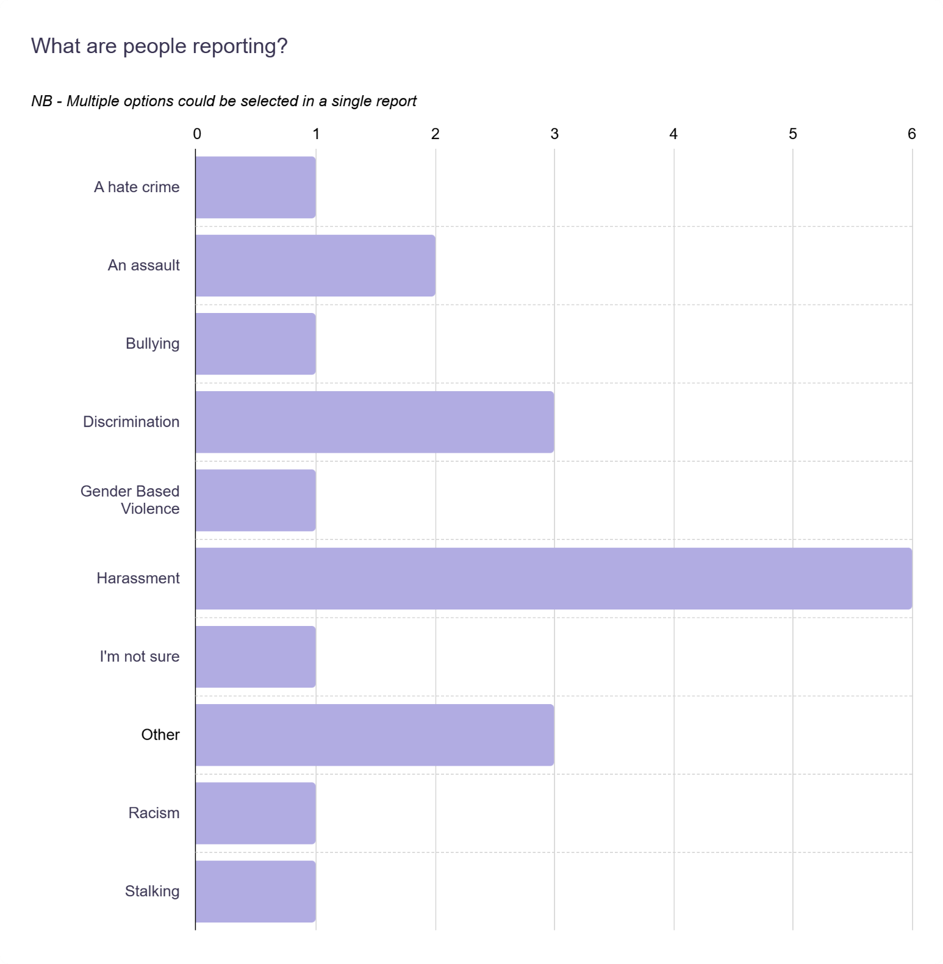

**Partner of Choice & Partnership Working- New Equality Outcome**

Following the comprehensive review of our progress, evidence and areas for improvement, we have decided to establish a fifth equality outcome focused on becoming a 'partner of choice' and enhancing partnership working. This decision is driven by several key factors and supported by evidence and strategic considerations.

**Financial Challenges and Smarter Working (include this?)**

The financial challenges facing the education sector necessitate smarter working practices across the college. By encouraging strong partnerships, we can pool resources, knowledge and share expertise. This approach not only helps us navigate financial constraints but also enhances the quality and reach of our services.

**Collaboration with Experts and Specialised Organisations**

Working with experts and specialised organisations allows us to leverage their knowledge and experience to better address more complex issues. We already have successful partnerships with organisations such as EmilyTest, LGBT Youth Scotland, Action for Children, and Brothers In Arms. These collaborations have proven beneficial in providing targeted support to our students and staff. It also helps us to raise awareness of their services and objectives with a wider audience.

**Enhancing Internal Partnerships**

While we have established internal partnerships across various departments, there is potential to further develop these relationships to embed EDI more deeply within our college culture. Strengthening internal collaboration will enhance our understanding of equality issues and ensure that EDI principles are integrated into more aspects of our operations.

**Supporting Disadvantaged and Underrepresented Groups**

As a partner of choice, Glasgow Clyde College aims to support individuals from disadvantaged backgrounds and underrepresented groups. By partnering with charities, organisations, and agencies, it enables us to support our local communities more effectively.

The creation of this new equality outcome reflects our commitment to build strong, mutually beneficial relationships that enhance our capacity to support our students, staff, and the wider community.

# Glasgow Clyde College’s Equality Outcomes 2025-2029

Glasgow Clyde College's new Equality Outcomes 2025-2029

**Outcome 1**

**Glasgow Clyde College successfully attracts and employs a diverse workforce, particularly individuals from ethnic groups and disabled people, fostering an inclusive and innovative college environment.**

Related SFC NEOs:

* **Disability:** Increase the representation of disabled staff in the workforce and on college Boards.
* **Race:** Increase the racial diversity of teaching and non-teaching staff to align with student representation in the sector.

This also covers the protected characteristics of Pregnancy & Maternity and Marriage and Civil Partnership in our workforce.

Glasgow Clyde College’s commitment to attracting and welcoming all individuals, aligns with SFC's goals to increase representation of diverse groups in the workforce at all levels and the board of management.

Relevant PSED General Duty- Advancing Equality, Eliminating Discrimination & Fostering Good Relations

**Outcome 2**

**Everyone within our Glasgow Clyde College community feels a strong sense of belonging and safety, assured of their ability to thrive within a nurturing and aspirational environment.**

Related SFC NEOs:

* **Age**: The success rates for college students aged under 19 will improve
* **Disability**: Ensure disabled students report feeling satisfied with support and reasonable adjustments received.
* **Gender Reassignment:** Trans staff and students report feeling safe to be themselves in the tertiary system.
* **Race:** Staff and students feel supported and safe, confident that complaints of harassment or bias on the grounds of race will be dealt with appropriately.
* **Religion or Belief**: Students and staff report that they have confidence in institutional report and support mechanisms because they are fit for purpose.
* **Sex:** Staff and students know how to access support about violence, harassment, and abuse, and feel properly supported in doing so because the services are fit for purpose.
* **Sexual Orientation**: Lesbian, Gay and Bisexual staff and students report that they feel safe being ‘out’ at university & college

Glasgow Clyde College's commitment to a safe and inclusive environment aligns with SFC's focus on ensuring safety and support for everyone in our college community, tackling discrimination and providing support for those experiencing violence or harassment.

Relevant PSED General Duty- Advancing Equality, Eliminating Discrimination & Fostering Good Relations

**Outcome 3**

**Glasgow Clyde College strives to ensure all disabled people achieve their potential through appropriately promoted, accessible services and tailored support.**

Related SFC NEOs:

* **Disability:** Improve the success and retention rates of students who declare a mental health condition. Ensure disabled students report feeling satisfied with support and reasonable adjustments received.
* **Sex**: Men (staff and students) know how to access mental health support (recognising intersectionality within that group).

Glasgow Clyde College underlines its commitment to the success and well-being of disabled individuals, with a focus on providing accessible services and tailored support for all. This also includes the importance of promotion and accessibility of services for positive male mental wellbeing support.

Relevant PSED General Duty- Advancing Equality & Eliminating Discrimination

**Outcome 4**

**Glasgow Clyde College ensures staff are equipped to deliver an inclusive and diverse curriculum that reflects and benefits our student population.**

Related SFC NEOs:

* **Race:** Ensure the curriculum is diverse and anti-racist. Address attainment levels by racial group.
* **Age**
* **Sexual Orientation**
* **Disability**
* **Gender Reassignment**
* **Religion or Belief**
* **Sex**

Glasgow Clyde College’s goal to deliver an inclusive curriculum aligns with SFC's emphasis on ensuring that the curriculum is both diverse and anti-racist to help address racial attainment gaps.

Relevant PSED General Duty- Advancing Equality, Eliminating Discrimination & Fostering Good Relations

**Outcome 5**

**Glasgow Clyde College is the partner of choice in meeting diverse needs, advancing collaboration and achievement for all members within our college community.**

Related SFC NEOs:

* **Religion or Belief:** Students and staff report confidence in institutional report and support mechanisms.
* **Sex:** Institutions address significant imbalances on courses and take action to rectify them.
* **Sexual Orientation**: Lesbian, Gay and Bisexual staff and students report that they feel safe being ‘out’ at university & college
* **Disability**
* **Gender reassignment**
* **Age**
* **Race**

Glasgow Clyde College's focus on collaboration, partnerships and meeting diverse needs aligns with SFC's goals to address attainment gaps, decrease withdrawal rates, ensure confidence in support mechanisms, enhance safety on campus and reduce imbalances in course representation.

Relevant PSED General Duty- Advancing Equality, Eliminating Discrimination & Fostering Good Relations

# Looking Forward

“Looking ahead, we will reinforce our steadfast commitment to equality, diversity, and inclusion in our new strategic plan, which will be launched in late 2025. This plan will outline our continued efforts to promote an inclusive culture where everyone is respected, empowered, and provided with equal opportunities to succeed.” Jon Vincent, Principal & CEO Glasgow Clyde College

The SFC's National Equality Outcomes focus on tackling significant inequalities that affect various groups across Scotland. The SFC encourages institutions to adopt these outcomes and integrate them into their strategic planning to ensure a cohesive approach to advancing equality.

To ensure the successful implementation and monitoring of these outcomes, we have developed a comprehensive SMART Plan. This plan sets Specific, Measurable, Achievable, Relevant, and Time-bound objectives, providing a clear roadmap for achieving our equality goals.

The Equality, Diversity, and Inclusion (EDI) Committee will play a crucial role in overseeing the progress of the SMART Plan. The committee will regularly review data, assess progress, and provide guidance to ensure that we stay on track. By engaging with stakeholders, and utilising their insights, the EDI Committee will help adapt our strategies as needed and ensure that our efforts are effective and impactful.

We will also work collaboratively with our Board to identify meaningful Key Performance Indicators (KPIs) for EDI within Glasgow Clyde College and agree governance reporting protocols to our EDI Committee regarding progress toward our new Equality Outcomes.

The College is currently developing new self-evaluation protocols as we embark on our quality journey with QAA.  This will enable us to consider the best ways to embed and reflect upon EDI within the curriculum and support services and highlight the extensive partnership working that we undertake with external organisations.  We have submitted our initial Self Evaluation Action Plan and will be discussing our quality evolution with QAA over the coming months and years as we continuously improve of learning, teaching and support services across the College.

We look forward to advancing these outcomes and engaging with stakeholders to ensure meaningful developments. In two year's time, we will report on our progress, reflecting on successes and identifying areas for further improvement. Together, we will continue to build a college community where everyone feels valued and supported.

Please see a copy of our new plan template in **Appendix A – SMART ACTION PLAN**

